Data Structures &algorithms

USING JAVA LANGUAGE



SAIF HADDAD

21110214

**Part 1:**

**Q1)**

**The definition of a Priority Queue:**

is an Abstract Data Type (ADT) that functions like a regular queue but with each element having a different priority. (Priority queue, 2017)

**Note:** Priority queues can only handle comparable information. (Priority queue, 2017)

**The definition of a Min-Priority Queue:**

A Min-Priority Queue is a data structure that manages a collection of elements, every element in the queue is connected to a priority value, and the element that has the least priority value is always at the head of the queue. This data structure is often implemented using a linked list. In this approach, every element and the priority of each element will be stored in a linked list data structure. (Priority queues, 2022) (Java Priority Queue, 2023) (great learning, 2021) (queue implementation, 2022)

Each element in a Min-Priority Queue using a linked list will be identified by a node with two parts: one for the element (Data) and one for the priority value. The nodes are connected one after the other in a list using pointers (node), each node holding a reference to the following node (Next address). (Priority queues, 2022) (Java Priority Queue, 2023) (great learning, 2021) (queue implementation, 2022)

**Note:** If two elements have the same priority value, they will be served based on their order in the queue

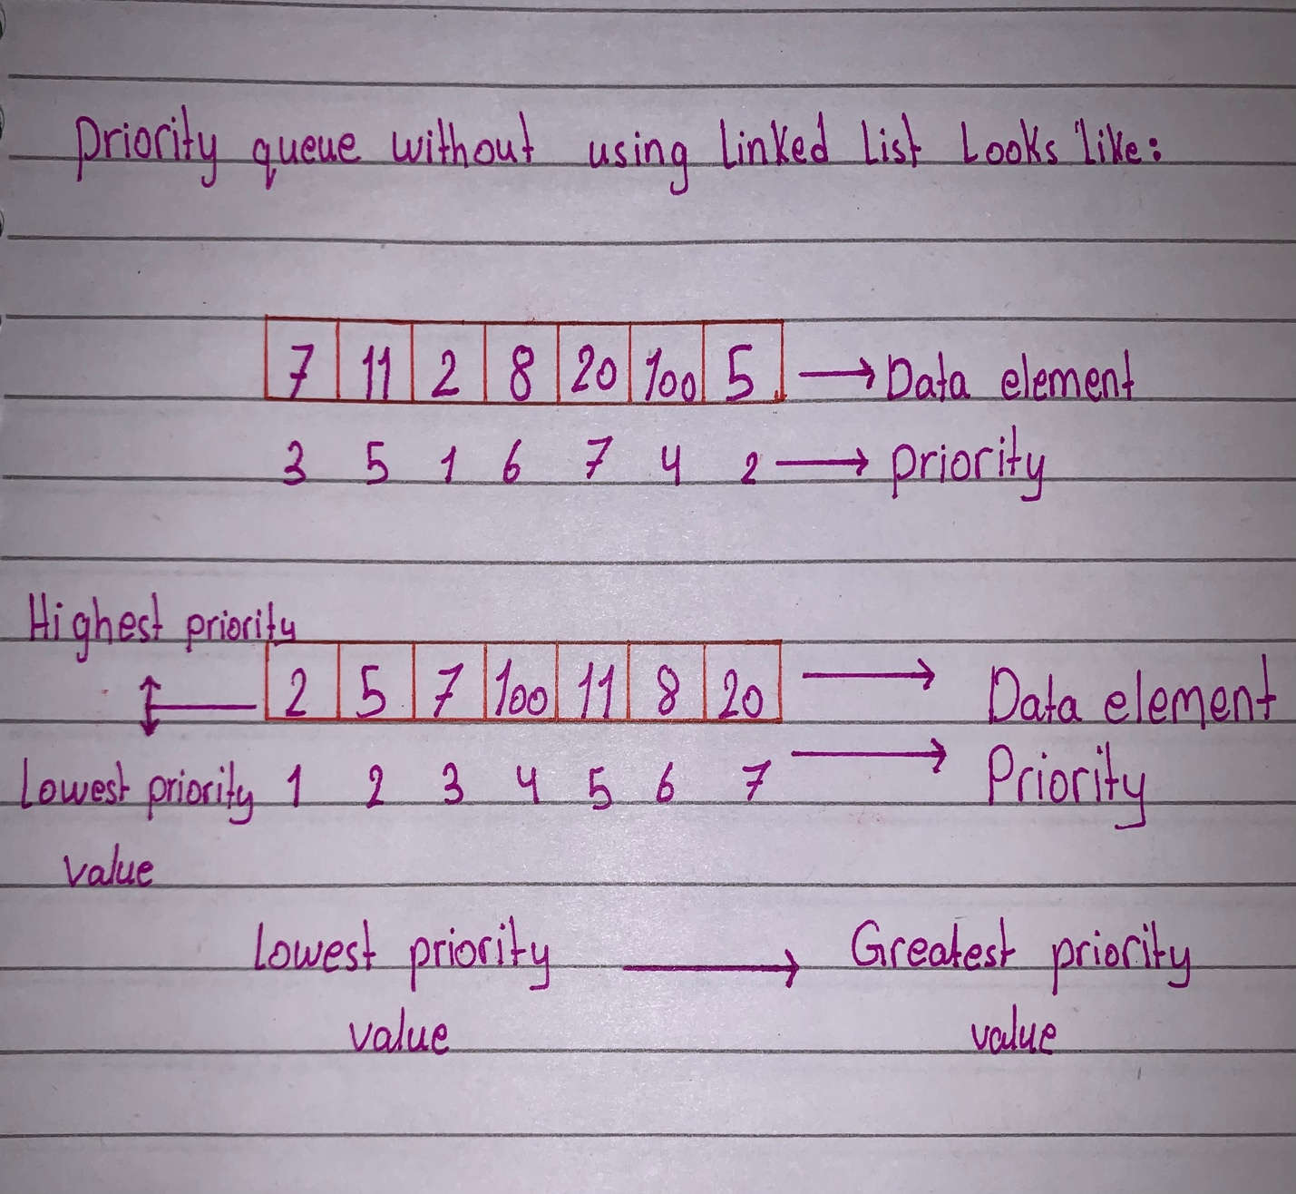

This is the simplest way to understand what a min-priority queue is.

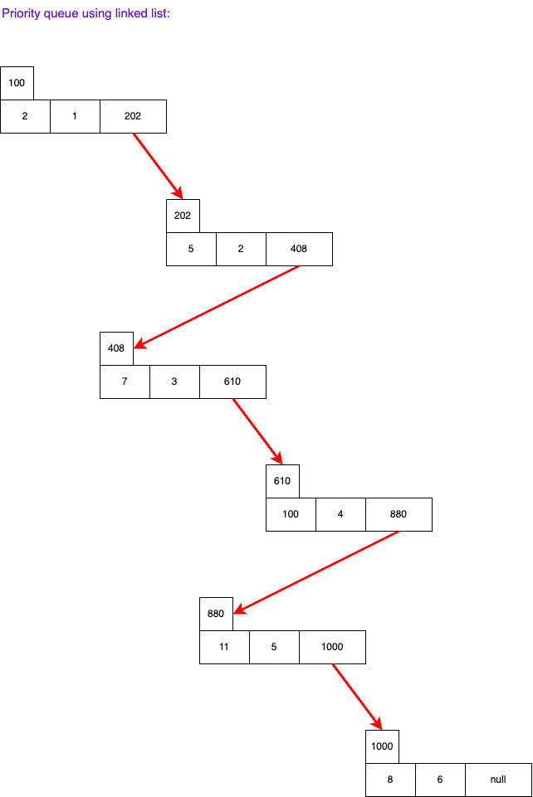

**The application of a Min-Priority Queue:**

**1-Hospital Emergency Department:**

The scenario is that patients come at different times and with different levels of severity.

Every patient will be an element of the Min-Priority Queue. The severity of each patient's condition will determine the priority given to them; the more serious the condition will have the higher the priority

The removeMin operation is used to choose the patient with the greatest priority, which is the least priority value (the most serious condition) for treatment when a doctor becomes ready to visit a patient. The most urgent situations are always handled first in this way.

The getMin operation can be used to determine who is going to be treated next. The queue will not change, but the patient with the greatest priority will be identified.

The insert operation can be used to add patients to the queue with the proper priority as they come in or when the conditions of current patients change.

(codingninjas, 2022) (Alipour-Vaezi et al., 2022)

**2- Operating Systems:**

Different activities or tasks may produce interruptions in computer systems, requiring the CPU to respond right away. These interruptions may range in priority or urgency.

These interruptions can be effectively handled using a Min-Priority Queue. Each interruption request is put in a queue with a priority based on how urgent it is.

The interrupt with the most urgency (lowest priority value) is then automatically taken out of the queue and processed by the system.

The system makes sure that it always handles the most important interrupt requests first by employing a Min-Priority Queue.

(codingninjas, 2022) (Applications of priority queue, 2023)

**The main operations of a Min-Priority Queue:**

**1-Insert ( ):**

Using this function means that a new element with the specified priority will be added to the priority queue. this action includes creating a new node with the element (Data) and its priority and addingthe element to the linked list according to that priority.( javatpoint, 2023) (Priority queue using linked list, 2023)

**2- getMin ( ):**

Using this function will get the element (Data) that have the least priority value in the linked list priority queue without deleting it.

**Note:** the element that has the least priority value, has the highest priority.

( javatpoint, 2023) (Priority queue using linked list, 2023)

**3- removeMin ( ):**

Using this function will get the element (Data) that have the least priority value in the linked list priority queue and then delete it from the priority queue, then the element that is after the one that was deleted become the head of the priority queue, that means it will take the position of the deleted one. ( javatpoint, 2023) (Priority queue using linked list, 2023)

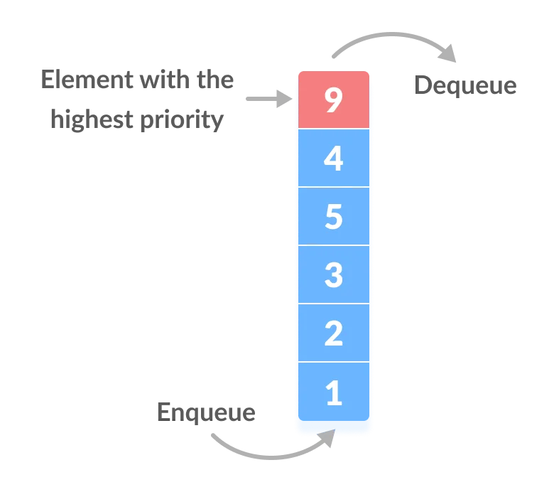

Insert();

removeMin();

This is the main concept of the two functions: Insert and removeMin.

This picture shows the functions without using the linked list.

The difference is just that we use a Node that contains the element and the priority:

**The time complexity of each operation:**

**1-Insert ( ):**

In the case of using the insertion function, we will need to go through all the elements that are in the linked list to find the right place (position) to add the new element (node) based on the value of the priority, so this procedure will take O(N) because we don’t know how much elements we will go through to find the right place for the new node ( javatpoint, 2023)

**2- getMin ( ):**

In the case of using the insertion function, it will take O(1) because only the first node of the linked list will be accessed. The element with the lowest priority will always be found in the first node of the linked list since it is kept in order of sorting by priority. ( javatpoint, 2023)

**3- removeMin ( ):**

In the case of using the insertion function, it will take O(1) because only the first node of the linked list has to be removed and returned. The element with the lowest priority will always be found in the first node of the linked list since it is kept in order of sorting by priority. ( javatpoint, 2023)

**Q2)**

**Empty priority queue:**

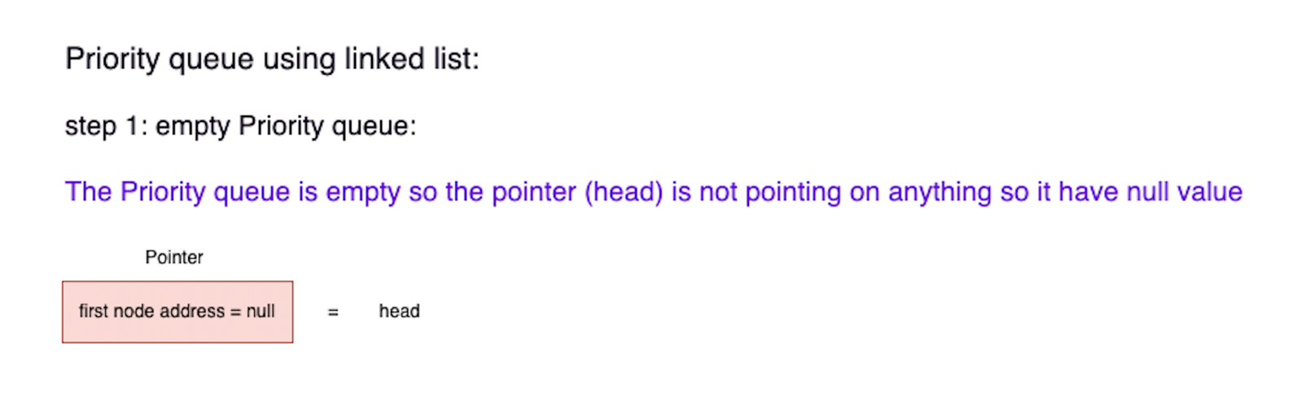

**Priority queue after applying multiple operations:**

**1-Insert ( ):**

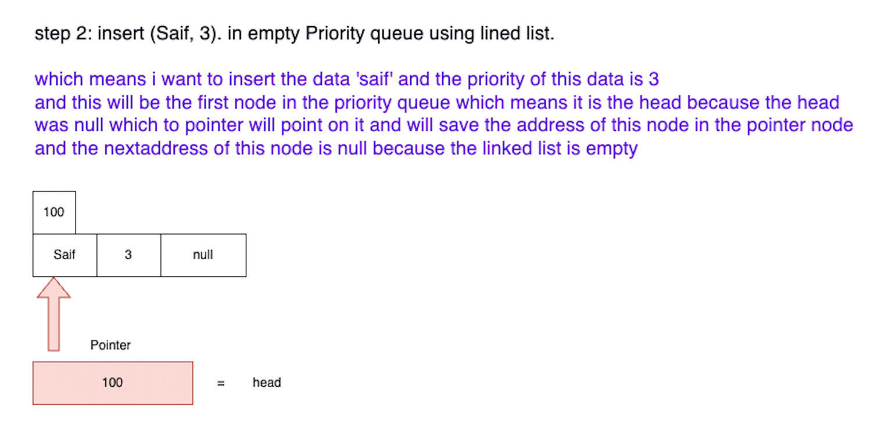

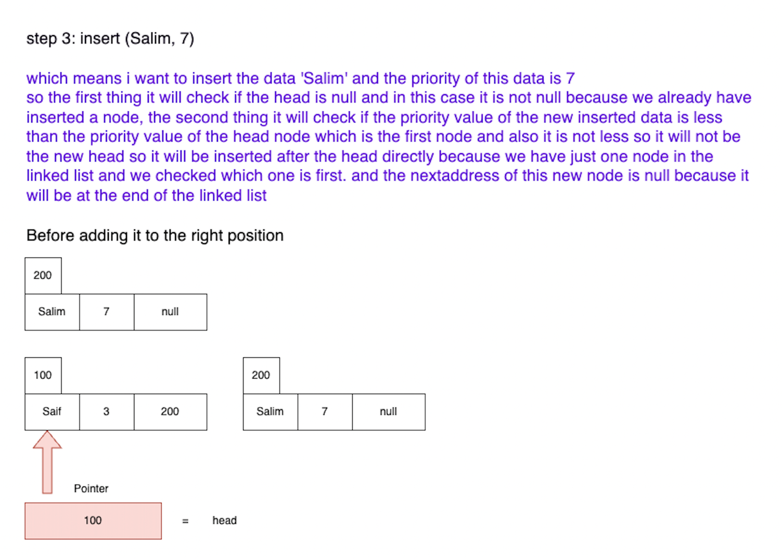

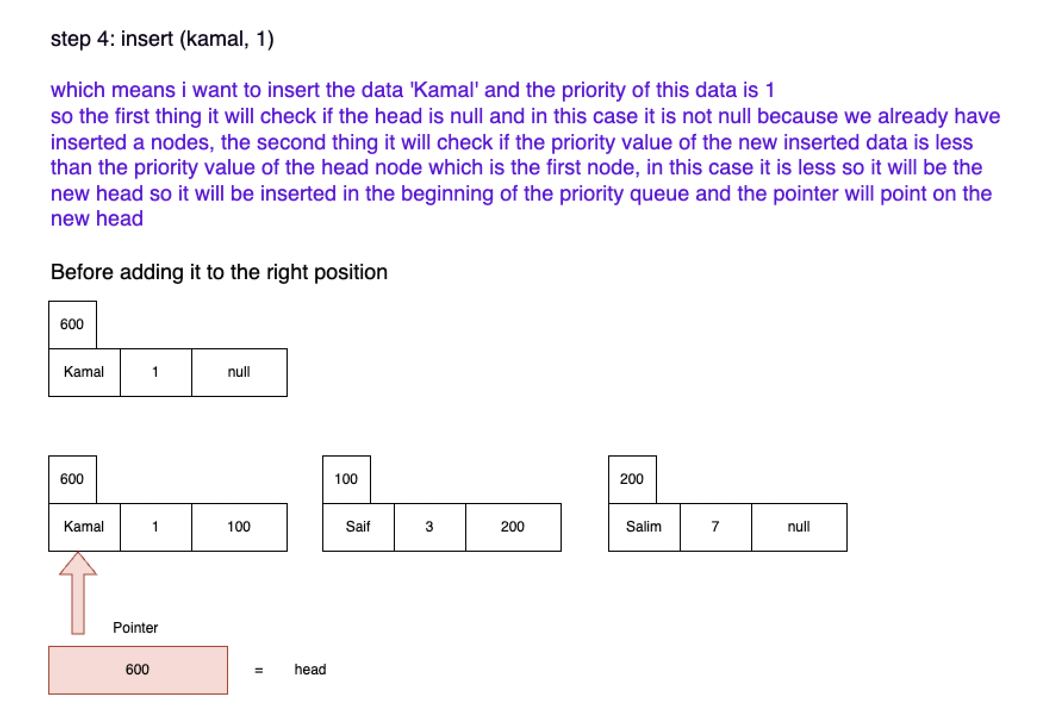

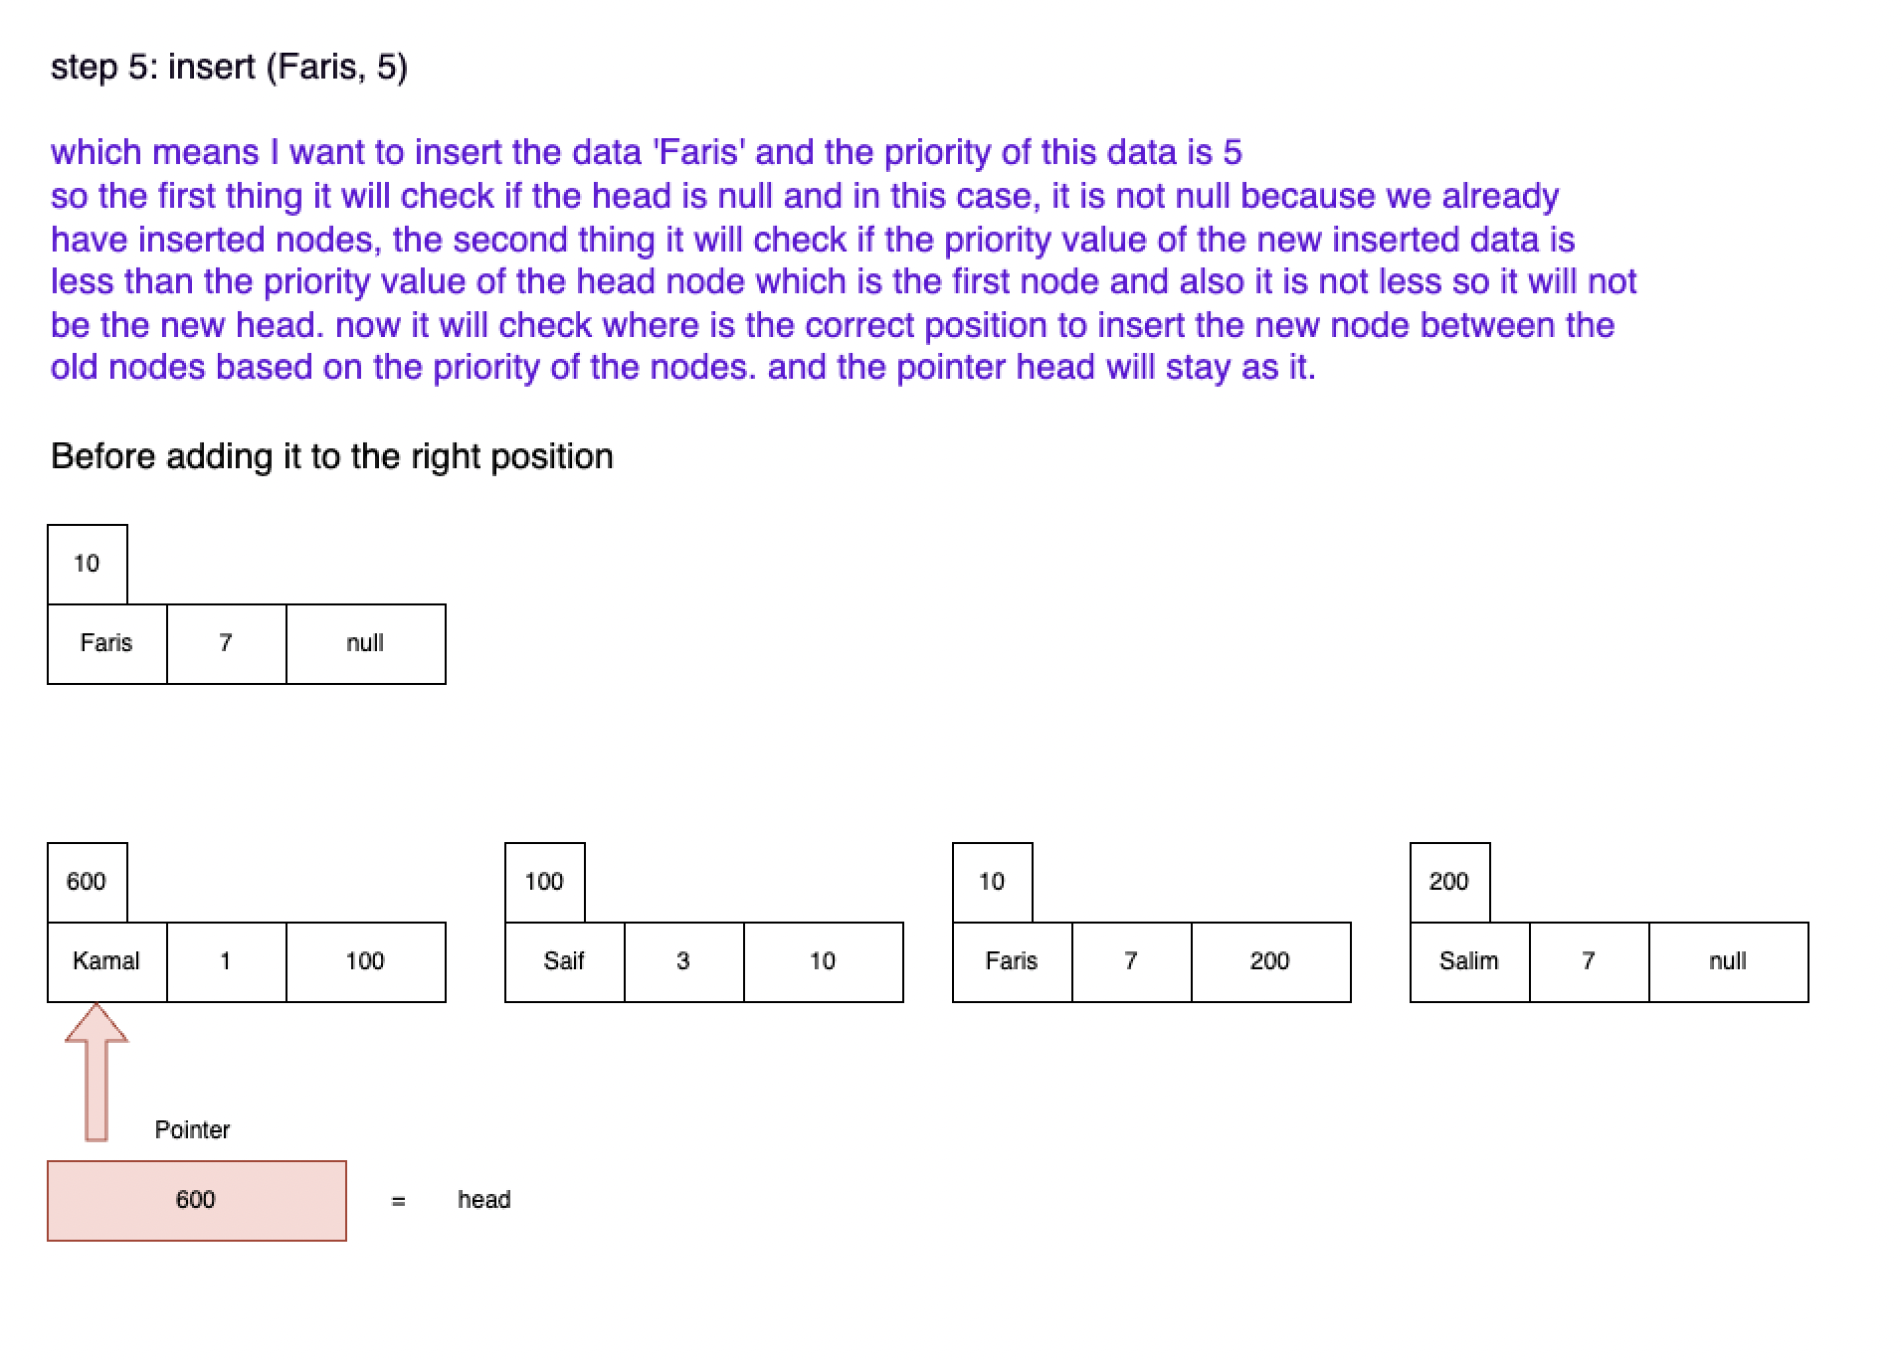

**2- removeMin ( ):**

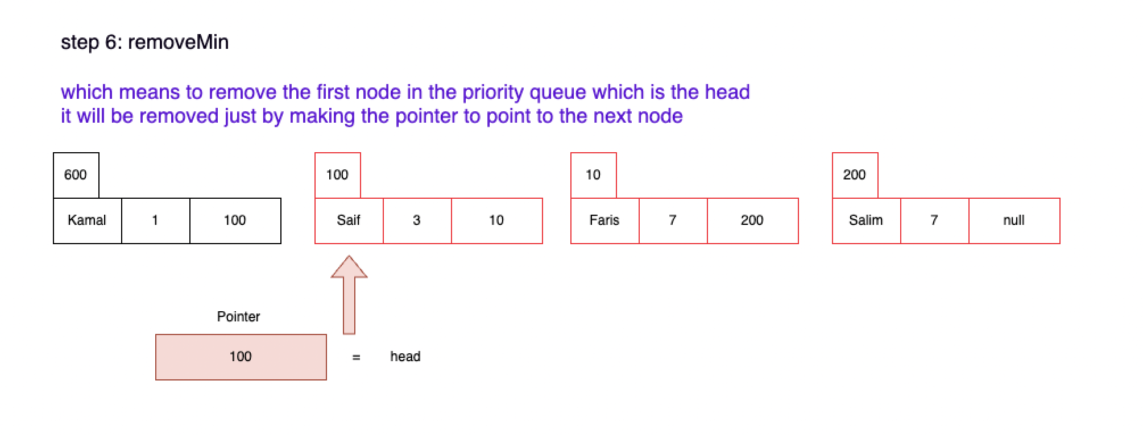

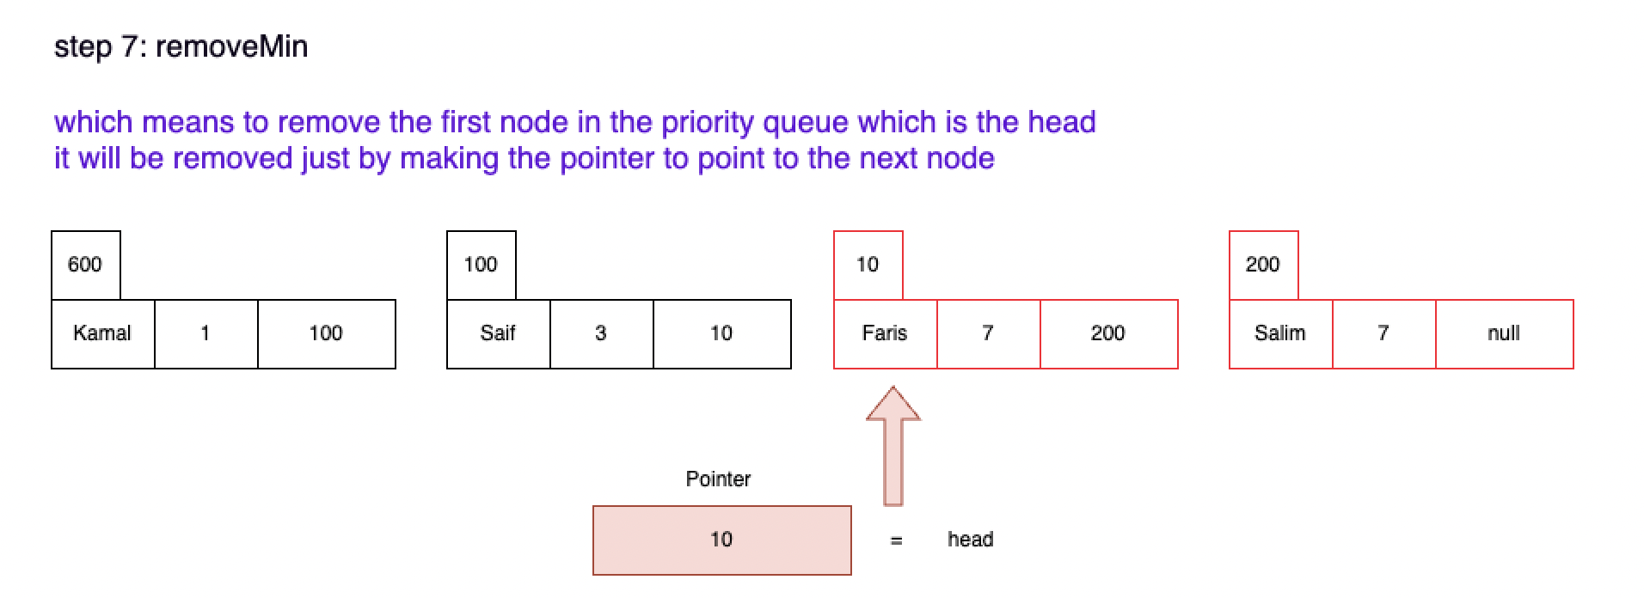

**3- getMin ( ):**

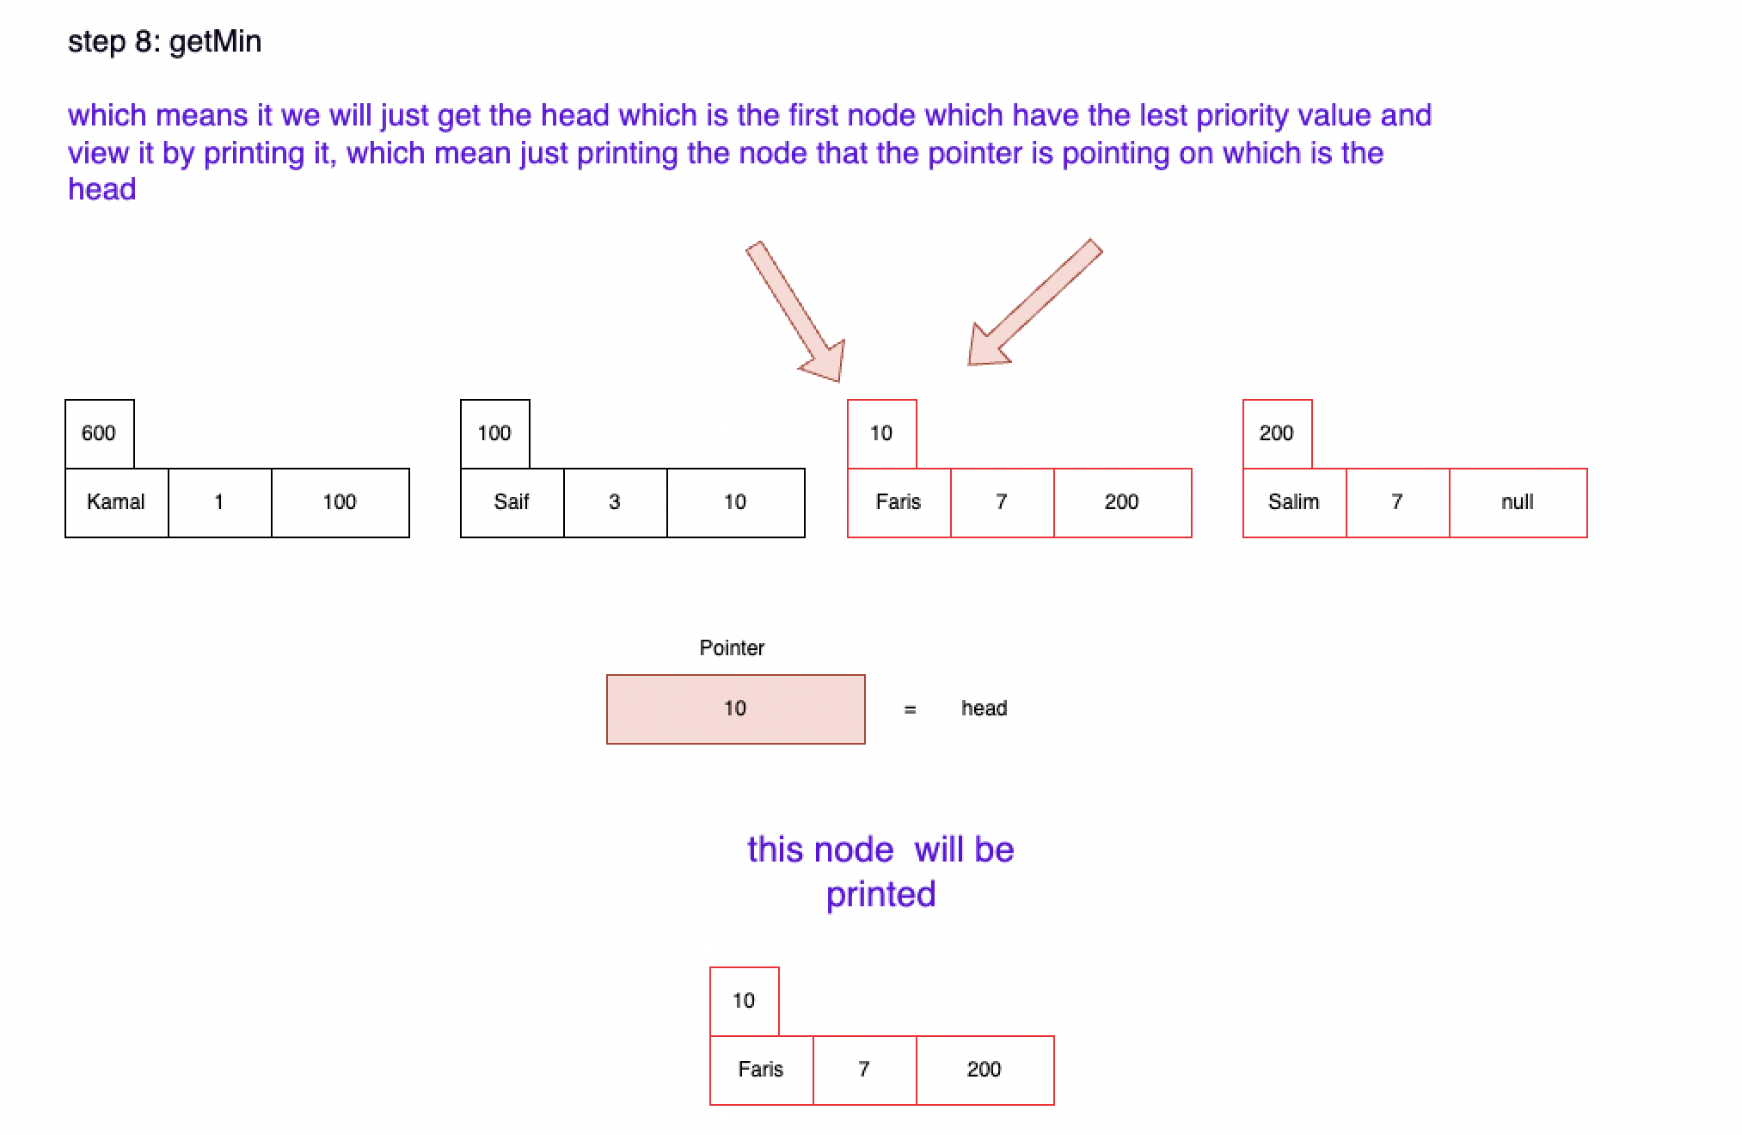

**Part 2:**

|  |  |  |  |  |
| --- | --- | --- | --- | --- |
|  | | **5000** | **50000** | **500000** |
| **Selection Sort** | **Sorted** | 37.945708 | 523.655958 | 321420.530666 |
| **Reversely Sorted** | 34.45275 | 3202.131125 | 320761.880083 |

**Some of the reasons why there is a difference between the actual running time in the sorted array vs the unsorted array.**

Other systems may be running at the same time while running the algorithm

It's also reasonable that the specific Selection Sort implementation used for this test will behave strangely depending on the input. For instance, because of how it handles equal items or the complexity of some unneeded checks or operations that it conducts regardless of whether the array is already sorted, it could be somewhat less efficient when working with previously sorted arrays, some of these operations like if statement…...(datatrained, 2023)

Also, to put in mind in some situations when the actual running time for the unsorted array is bigger than the sorted array that’s because of the number of swaps that might happen.

Also, the battery level and the CPU of your own computer can affect the actual running time

(datatrained, 2023)

|  |  |  |  |  |
| --- | --- | --- | --- | --- |
|  | | **5000** | **50000** | **500000** |
| **Merge Sort** | **Sorted** | 14.095875 | 6.456334 | 68.022584 |
| **Reversely Sorted** | 0.576459 | 6.009209 | 27.5485 |

**Some of the reasons why there is a deference between the actual running time in the sorted array vs the unsorted array.**

A sorted array may take a little bit longer to sort using Merge Sort in actual implementations due to a variety of causes. One of the causes might be the Merge Sort algorithm's recursive calls, which must be made no matter if the input was already sorted. For instance, the technique divides an array into half even if it is sorted up until it reaches single-element arrays of values, and then get put back together. (datatrained, 2023)

On the other hand, certain implementations might benefit from specific data characteristics or optimizations when the array is unsorted. For instance, how well a certain machine or programming language supports recursion or how memory is handled while the algorithm is being executed might have an impact on the running time. (datatrained, 2023)

It's also important to note that the variances between the times I supplied are small and are expressed in milliseconds. Instead of being significant differences in the algorithm's execution time, they may be within the measurement's range of error, or they could represent accidental conditions like other processes operating on the same computer. (datatrained, 2023)

**Q4)**

|  |  |  |
| --- | --- | --- |
|  | **Selection Sort** | **Merge Sort** |
| **Best case** | O(n2) | O(n log n) |
| **Worst case** | O(n2) | O(n log n) |

Merge Sort has an in-time complexity that is always O(n log n) no matter the condition of the input at the beginning. This is because of the reason that Merge Sort, a divide-and-conquer algorithm, divides the data being input into halves, sorts them separately, and then combines them. Regardless of whether the data is previously sorted, or reversed, this technique still applies.

1- We do not include the "divide" step in the Big O notation since its execution time is constant no matter the dimension of the array.

2- As a result of every in each list finally being examined once only once the sorted lists are combined, the "conquer" phase, which combines two sorted arrays into one, executes in linear time (O(n)).

3- We end up with an overall amount of log(n) layers (base 2) doing O(n) work, with each layer of recursion halving the size of the array and including a merging operation that executes in linear time. The ultimate time complexity as a consequence is O(n log n).

Selection Sort always has an O(n2) time complexity. When using a selection sort, the smallest (or biggest, depending on the sorting sequence) element from the list's unsorted part is repeatedly chosen and moved to the list's sorted section. Even when the list has been sorted before, it still does this. As a result, even in the best case where the input has already been sorted, it still comes with an O(n2) time complexity since it misses the sorted order and continues to choose each element individually.

**Q5)**

**Information about the merge sort:**

splits the array in half and sorts each half individually. The complexity of time is the same no matter how the data is sorted or reversed. It will still split and merge the same total of times, so the processing time will remain O(n log n).

**Information about the selections sort:**

Selection Sort always takes the same period of time to finish, regardless of whether the input data is sorted or reversed. Finding the smallest (or biggest, depending on whether the sort is going up or decreasing) element in the array's unsorted part and moving it to the beginning of the section that is sorted is how it works. The time complexity of this process is O(n2) since iterating over the list's unsorted section each time includes going through each entry.

**Which one is better:**

Merge Sort.

**Why the Merge Sort is better:**

Merge Sort performs better than other algorithms, such as Selection Sort, because of the way it scales with bigger data sets. As the size of the data set (n) increases, the number of operations needed also increases at a rate equal to n log n due to the time complexity of Merge Sort, which is O(n log n).

Due to this divide-and-conquer strategy, the list split procedure in Merge Sort is logarithmic, resulting in the 'log(n)' element of its time complexity. While every item in each list will finally be reviewed just once until the sorted lists merge, resulting in the 'n' element, the merging process is linear. The overall time complexity, as a result, is O(n log n).

As a result, during the merging process, every element is looked over and placed once, but in the selection sort in every iteration the element will be checked so it depends on the size of the set so the element will be checked more than time which will take more time.

On the other hand, the number of operations needed increases with a rate equal to n squared for time-complexity O(n2) algorithms like Selection Sort. As a result, Selection Sort will take a lot more operations than Merge Sort for bigger data sets.

Since it needs to produce copies of the list to complete the merging step, merging Sort needs more space in the memory than a lot of other sorting algorithms, but this additional memory usage may be an acceptable cost given the speed boost on bigger data sets.

|  |  |  |
| --- | --- | --- |
|  | **Merge sort** | **Selection sort** |
| **Performance on Sorted Data.**  **Best case.** | Fast **O(n log n)** | Slow **O(n2)** |
| **Performance on Reversely Sorted Data.**  **Worst case.** | Fast **O(n log n)** | Slow **O(n2)** |
| **Space Usage** | Use more space **O(n)** | Use less space **O(1)** |

**Q 6:**

**How did I get the results (actual time):**

I calculate the starting time which is the time before calling the sorting algorithm, then I calculate the end time which is the time immediately after finishing the sorting then I subtract the two values that I have got so I can have the real-time of sorting the array.

**Start explaining and comparing the real-time with the theoretical time of the selection sorting algorithm:**

The time complexity of the selection sort is O(n2). This indicates that if you expand the array's size by k, there will be an increase in time of about k2.

**Note:** An expression "factor of k" describes a ratio. A value gets multiplied or divided by k when anything grows or reduces by a "factor of k".

**5000 Elements:** The actual running time is significantly lower than the 25,000,000 square of the input size (50002), though. Big O notation, which is a reduction used to define the maximum level of temporal complexity, may be used to illustrate this. It ignores constant multiplication factors and focusses on the term (n2) that is going to have the most influence as n rises.

**50,000 Elements:** The input size has increased by a factor of ten. We expect a tenfold increase in running time if the complexity of time were linear. The running time increases by nearly a factor of 100 (from around 35-38ms to about 523-3202ms), however, because the time complexity is O(n2). This demonstrates that the execution time does not increase linearly but rather quadratically with the amount of the input.

**500,000 Elements:** Once more, the input size is ten times larger than the last one. The running time increases by nearly a factor of 100 (from around 523-3202ms to about 320420-320761ms), which is consistent with the O(n2) time complexity because it is quadratic.

It is fair to assume that O(n2) has a quadratic time complexity given that the running time increases by about 100 times while the input size increases by a factor of 10. Since selection sort doesn't take advantage of the array's initial sortedness, it performs generally the same if the array is at first sorted or not, which is according to the theoretical analysis of selection sort. The running times for the sorted and unsorted arrays are similar.

In conclusion, Selection Sort possesses a quadratic time complexity (O(n2)), which indicates that as the amount of the input rises, so does the running time. The results presented support this as we see an approximately by one hundred increase in running time for every tenth increase in input size. Because of its quadratic time complexity, Selection Sort is efficient for smaller arrays but becomes less so as the input size grows.

**Start explaining and comparing the real-time with the theoretical time of the merge sorting algorithm:**

The time needed to complete a merging sort should grow a little more than linearly but far less than quadratically as the input size increases.

**5000 Elements:** An unsorted array's operating time is around 0.58 ms, while a sorted array's running time is roughly 14.1 ms. Merge Sort's time complexity (O(n log n)) tells us that there is an increase in running time that is quicker than linear (O(n)) however slower than quadratic (O(n2)) as the input size grows.

**50,000 Elements**: The input size is ten times bigger than it was before. We could expect a roughly 10 times increase in running time if time complexity were linear. However, the increase is less smaller since the time complexity is O(n log n). Although the running time rises (from around 0.58-14.1ms to roughly 6.0-6.5ms), it does not increase by a factor of 10. O(n log n) time complexity, which increases faster compared to a linear and slower quadratic function.

**500,000 Elements**: This input size is once again 10 times bigger than the previous one. The running time does rise, but not about a factor of 10 (from a range around 6.0-6.5ms to approximately 27.5-68.0ms), according to the same logic. This is proof that the Merge Sort functions as expected given its O(n log n) time complexity.

Therefore, for an algorithm with O(n log n) complexity, the execution time does not rise 10 times when the input size does (in your case, from 50,000 to 500,000). This is because the running time's rate of growth is slowed down by the logarithmic factor (log n).

Because of the linear part (n), the running time increases at a rate that is exactly equal to the size of the input as it increases. Because of the logarithmic factor (log n), the execution time increases along with the input size but at a slower rate.

In conclusion, when the input size grows by a factor of 10, the running time doesn't rise linearly (by a factor of 10) nor does it expand quadratically (by a factor of 100). Instead, it increases at a rate that is above linear and less than quadratic, which is in keeping with the O(n log n) time complexity of Merge Sort.

**Q7)**

**Another measure to test the efficiency of the used algorithm:**

**Space Complexity:**

The space complexity of an algorithm estimates how much memory or storage it needs to run as a function of the input's length. It stands for the greatest amount of space in memory needed for an algorithm to finish running.

Auxiliary space and space used by input are both considered parts of space complexity. While space used by input refers to the area needed to store input parameters, auxiliary space refers to the temporary or additional space used by an algorithm.

When a system has limited memory, the space complexity of an algorithm gets important, and it helps engineers in selecting the algorithm that uses the least amount of memory.

**if we want to use it for the merge sort:**

The space complexity of Merge Sort is O(n), which indicates that it needs more space equal to the input's number of elements. More space is required because Merge Sort splits and merges arrays, and it needs storage to make these extra arrays.

**if we want to use it for the selection sort:**

has a space complexity of O(1), which indicates that it takes up more space continuously. Selection Sort is a sorting technique that arranges the elements in the array by continually choosing the smallest element of the unsorted section and placing it at the start. As a result, it doesn't require extra space for storing temporary arrays.

**Q8)**

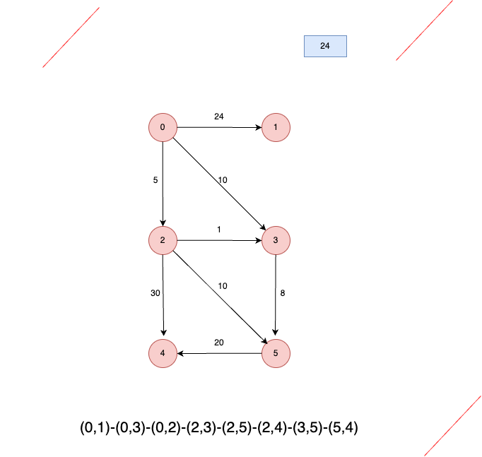

**Bellman-Ford algorithm:**

**First step we create pairs:**

(0,1)-(0,3)-(0,2)-(2,3)-(2,5)-(2,4)-(3,5)-(5,4)

**Starting with the first pair (0,1):**

The value of the vertex 0 = 0

The value of vertex 1= ∞

The weight of the line between the vertices =24

So 0 + 24 = 24

We ask our self if 24 is less than ∞ ?? the answer is yes so the value of vertex 1 = 24

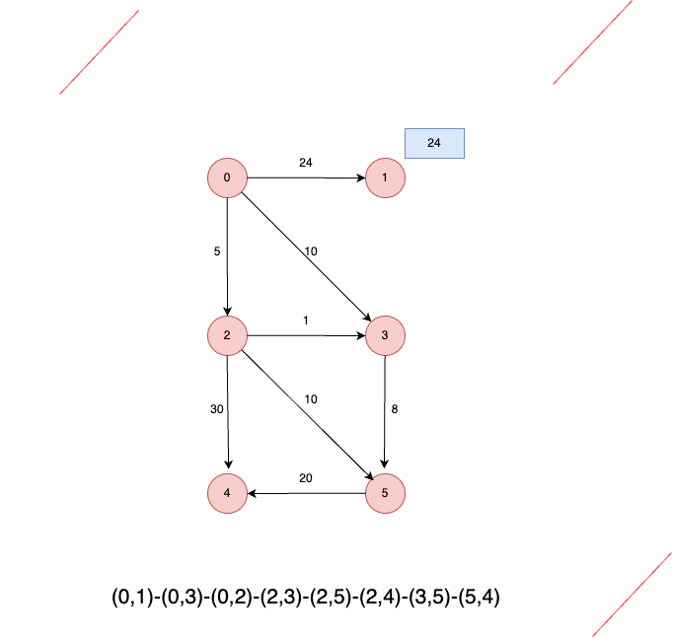

**Moving on to the second pair (0,3):**

The value of the vertex 0 = 0

The value of vertex 3 = ∞

The weight of the line between the vertices = 10

So 0 + 10 = 10

We ask our self if 10 is less than ∞ ?? the answer is yes so the value of vertex 3 = 10

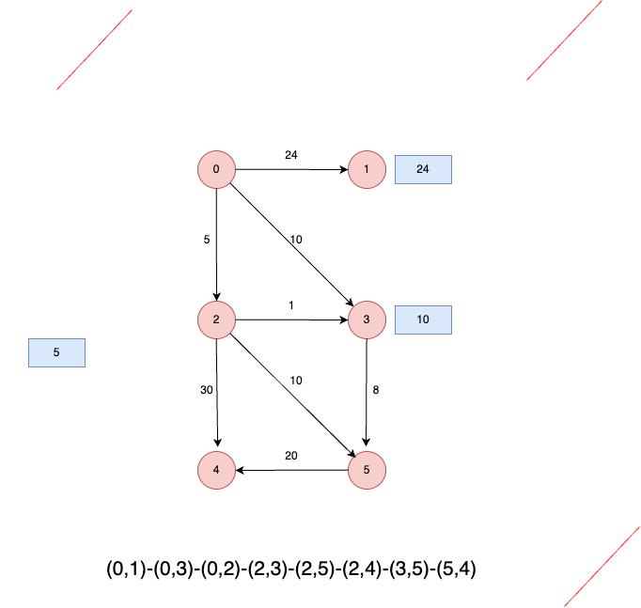

**Moving on to the third pair (0,2):**

The value of the vertex 0 = 0

The value of vertex 2 = ∞

The weight of the line between the vertices =5

So 0 + 5 = 5

We ask our self if 5 is less than ∞ ?? the answer is yes so the value of vertex 2 = 5

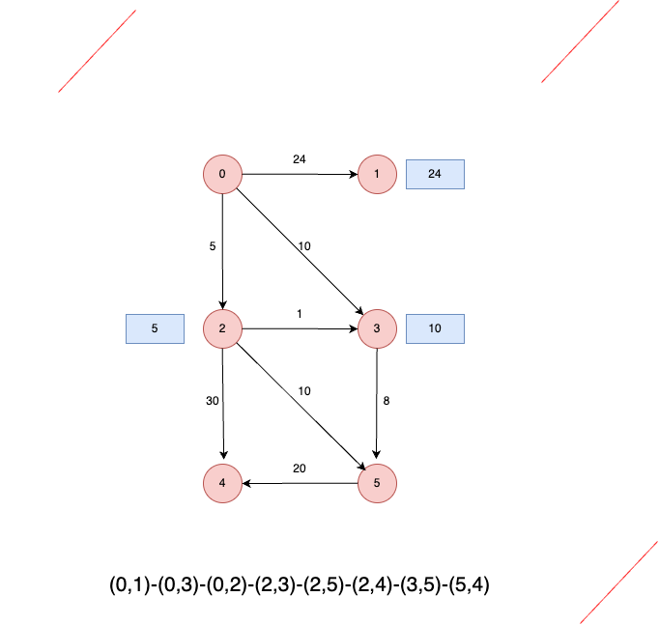

**Moving on to the fourth pair (2,3):**

The value of the vertex 2 = 5

The value of vertex 3 = 10

The weight of the line between the vertices = 1

So 5 + 1 = 6

We ask our self if 6 is less than 10 ?? the answer is yes so the value of vertex 3 will change from 10 to 6 .

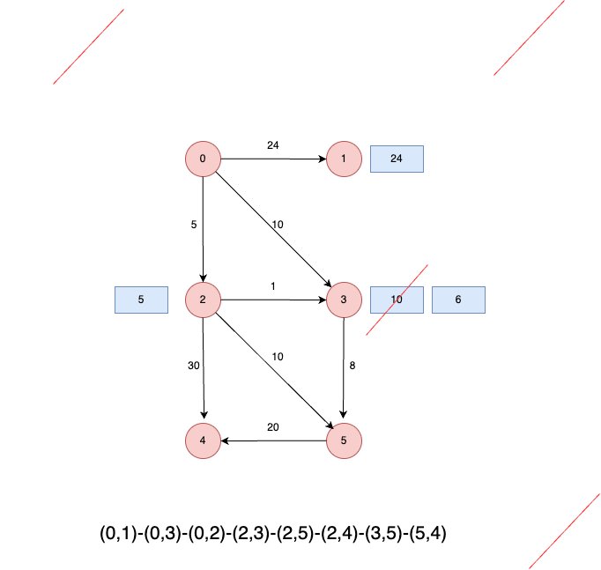

**Moving on to the fifth pair (2,5):**

The value of the vertex 2 = 5

The value of vertex 5 = ∞

The weight of the line between the vertices = 10

So 5 + 10 = 15

We ask our self if 15 is less than ∞ ?? the answer is yes so the value of vertex 5 = 15

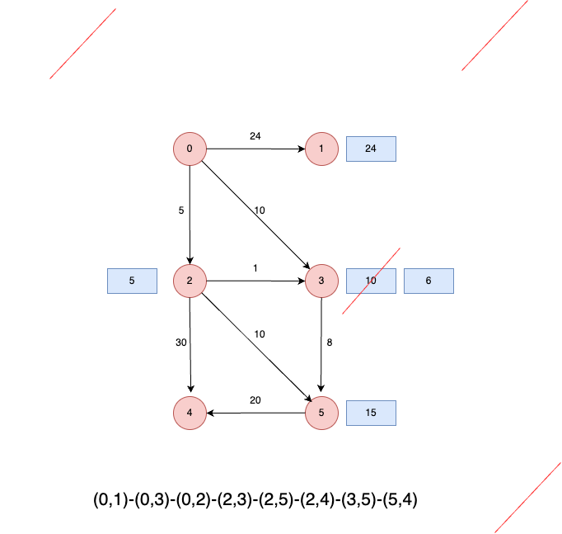

**Moving on to the sixth pair (2,4):**

The value of the vertex 2 = 5

The value of vertex 4 = ∞

The weight of the line between the vertices = 30

So 5 + 30 = 35

We ask our self if 35 is less than ∞ ?? the answer is yes so the value of vertex 4 = 35

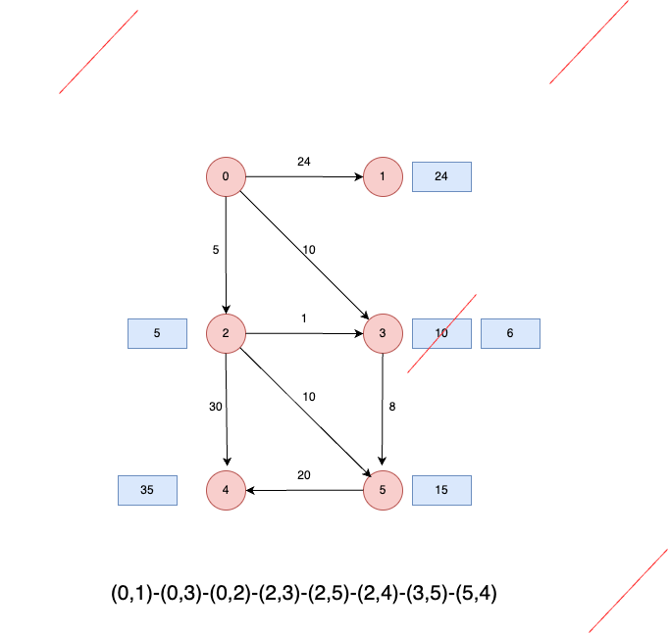

**Moving on to the seventh pair (3,5):**

The value of the vertex 3 = 6

The value of vertex 5 = 15

The weight of the line between the vertices = 8

So 6 + 8 = 14

We ask our self if 14 is less than 15 ?? the answer is yes so the value of vertex 5 will change from 15 to 14.

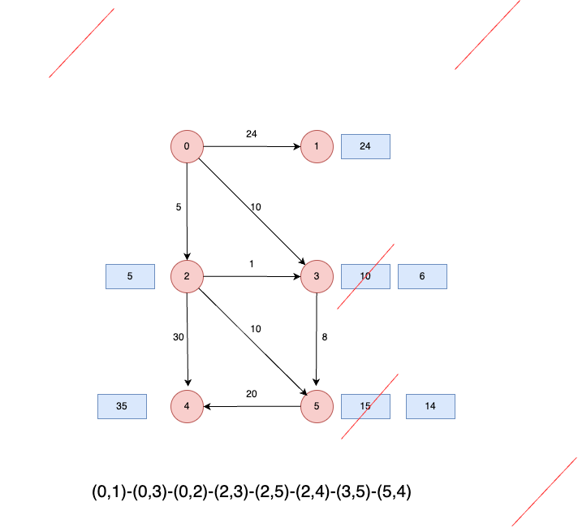

**Moving on to the eighth pair (5,4):**

The value of the vertex 5 = 14

The value of vertex 4 = 35

The weight of the line between the vertices = 20

So 14 + 20 = 34

We ask our self if 34 is less than 35 ?? the answer is yes so the value of vertex 4 will change from 35 to 34.

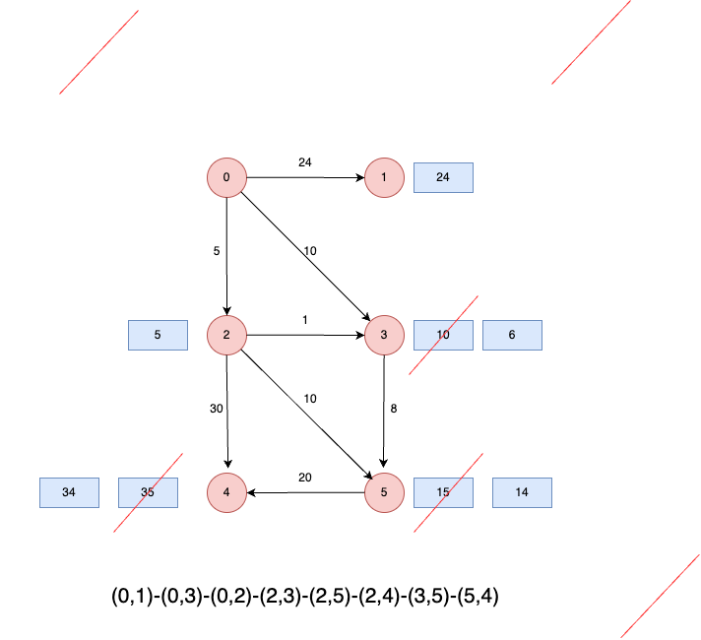

**So the shortest path between vertex 0 and 5 is to go from vertex 0 to vertex 2 then to vertex 5 (0, 2, 5)**

|  |  |  |  |  |  |  |
| --- | --- | --- | --- | --- | --- | --- |
| Iterations | 0 | 1 | 2 | 3 | 4 | 5 |
| 0 | 0 | ∞ | ∞ | ∞ | ∞ | ∞ |
| 1 | 0 | 24 | 5 | 6 | 34 | 14 |
| 2 | 0 | 24 | 5 | 6 | 34 | 14 |

As we can see that it takes just one iteration to find the shortest path.

**Dijkstra’s algorithm:**

Before starting all the shortest paths = infinity and all the previous nodes are empty

|  |  |  |
| --- | --- | --- |
| vertex | Shortest path | Previous node |
| 0 | ∞ | empty |
| 1 | ∞ | empty |
| 2 | ∞ | empty |
| 3 | ∞ | empty |
| 4 | ∞ | empty |
| 5 | ∞ | empty |

**The first iteration**

Starting from vertex 0 so the previous node will be unknown because it is the starting point.

And the value of the shortest path for vertex 0 will be 0 because the same reason that it is the starting node.

So we will see all the lines that are going out from the vertex zero which are the line that going to vertex 1, the line that is going to vertex 3 and the line that is going to vertex 2, and then we check all the weights between the vertex zero and all the mentioned vertices (1, 3, 2) to see the shortest paths between the vertex zero and the mentioned vertices as shown in the table, then we chose the lest weight so we can know what next node will be: the lest weight is 5 which is between vertex 0 and 2 so we will move to vertex 2.

|  |  |  |
| --- | --- | --- |
| vertex | Shortest path | Previous node |
| 0 | 0 | unknown |
| 1 | 24 | 0 |
| 2 | 5 | 0 |
| 3 | 10 | 0 |
| 4 | ∞ | empty |
| 5 | ∞ | empty |

As we can see in the first iteration we visited vertex 1, 2, 3 and the unvisited vertices were 4, 5

**The second iteration:**

as I mentioned that in this iteration, we will start from vertex 2.

So we will see all the lines that are going out from the vertex 2 which are the line that going to vertex 3, the line that is going to vertex 5 and the line that is going to vertex 4, and then we check all the weights between the vertex 2 and all the mentioned vertices (3, 4, 5) to see the shortest paths between the vertex 2 and the mentioned vertices as shown in the table, then we chose the lest weight so we can know what next node will be: the lest weight is 1 which is between vertex 2 and 3 so we will move to vertex 3.

|  |  |  |
| --- | --- | --- |
| vertex | Shortest path | Previous node |
| 0 | 0 | unknown |
| 1 | 24 | 0 |
| 2 | 5 | 0 |
| 3 | 6 | 2 |
| 4 | 35 | 2 |
| 5 | 15 | 2 |

As we can see that in this iteration all the vertices were visited.

**the third iteration:**

as I mentioned that in this iteration, we will start from vertex 3.

So we will see all the lines that are going out from the vertex 3, we found that there is just one line going out from vertex 3 and it is going to vertex 5 and the weight of this line is 8 as we can see in the table, so the next vertex will be 5

|  |  |  |
| --- | --- | --- |
| vertex | Shortest path | Previous node |
| 0 | 0 | unknown |
| 1 | 24 | 0 |
| 2 | 5 | 0 |
| 3 | 6 | 2 |
| 4 | 35 | 2 |
| 5 | 14 | 3 |

**The fourth iteration:**

as I mentioned that in this iteration, we will start from vertex 5.

So we will see all the lines that are going out from the vertex 5, we found that there is just one line going out from vertex 5 and it is going to vertex 4 and the weight of this line is 20 as we can see in the table, in this iteration we found that the shortest path to get to vertex four in to go form vertex 5 so we will update the shortest path for vertex four from 35 to 34.

|  |  |  |
| --- | --- | --- |
| vertex | Shortest path | Previous node |
| 0 | 0 | unknown |
| 1 | 24 | 0 |
| 2 | 5 | 0 |
| 3 | 6 | 2 |
| 4 | 34 | 5 |
| 5 | 14 | 3 |

**Note:** every time we visit a vertex we check if the new calculated shortest path is less that it value if yes we update the value with the new one

So the shortest way to go from zero to five id 0 – 2 – 3 – 5

**Part 3:**

**Q11)**

The data structure that I chose to solve this problem is a String data structure which is an array of characters.

**Pseudocode:**

Create a function with the name isit_Palindrome that takes a word

Define len as an integer which the same as the length of arr

Make a loop that starts from the first letter until the middle of the word that it is inserted.

define front as int that equals the array at index i

define back as int that equals the array at index len - i - 1

Convert front to lowercase if it's uppercase

If front is between 65 and 90 inclusive add 32 the number based on the ASKI codes

Convert back to lowercase if it's uppercase

If back is between 65 and 90 inclusive add 32 the number based on the ASKI codes

Check if front and back are different, If the letters are different tell me, or give a sign such as false.

End the loop

In case this condition was not executed end the loop and tell me that all pairs of characters are the same or give a sign such as true

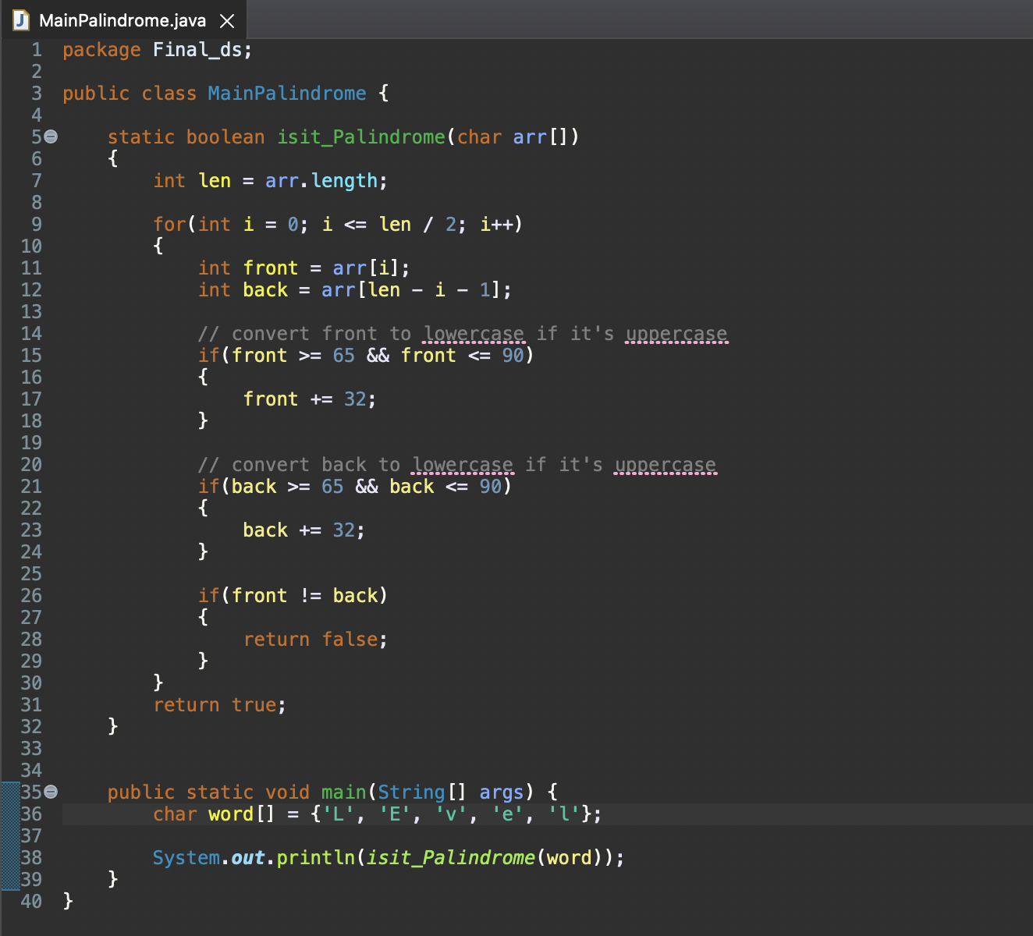

In conclusion, in this question, I have used an Array data structure and to be more specific it is a Character Array.

This reference for the ASCII codes (ASCII, 2022)

**Q12)**

**The formal definition of the array data structure:**

is a group of elements separated by index values. An array's elements are all the same type of data. An array's size must be specified when it is declared, and these elements will be stored in the memory. (S, 2023) (array, 2022)

**valid operations:** here are some operations that can be performed on an array:

**1- Insertion:** Add an element to the specified index. (Data Structures, 2022) (array, 2022)

**2-** **Deletion:** Delete the element at the specified index. To close the gap, move every element after that to the left. (Data Structures, 2022) (array, 2022)

**3-** **Traversal:** Go over each element in the array one by one. (Data Structures, 2022) (array, 2022)

**4-** **Access:** The element at a certain index can be retrieved or adjusted. (Data Structures, 2022) (array, 2022)

**5-** **Search:** If a certain element is present in the array, get its index. (Data Structures, 2022) (array, 2022)

**6-** **Update:** Put a new element in place of the element at the specified index. (Data Structures, 2022) (array, 2022)

**Illustration:** based on our scenario:

**1- Access:** We can read the first letter of arr, which is 'L,' as arr[0], and the last character, which is 'l,' as arr[4].

**2- Traversal:** The palindrome function compares the characters in equal locations as we move across the array from the ends to the center. In the first iteration, for instance, we contrast arr[0] ('L') with arr[4] ('l').

**3-** **Update**: In the function, if a character is capital (for instance, 'L'), we modify it to its lowercase counterpart by adding 32 to its ASCII value, essentially transforming 'L' to 'l'.

**4-** **Search:** We might look for a certain character in the array even though it isn't stated in my code and in my scenario. We may traverse over the array and compare each element to "v" until we find a match, for example, to get the index of "v".

**Q13)**

**This is the code:**

package Final_ds;  
public class stack {  
 public static void function2()

{

System.out.println ("lets start");

}

public static void function1(int arr[], int i)

{

if(i<0)

{

function2();

}

else

{

function1(arr, i-1);

System.out.println(arr[i]);

}

}

public static void main (String[] args)

{

int arr[] = {1,2,3,4,5};

function1(arr, 4) ;

function2();

}

}

**Before getting into the main the stack will be empty:**

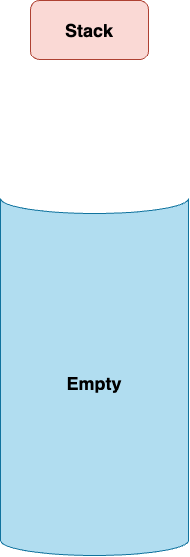

**Step 1:**

The main function was called.

public static void main (String[] args)

**The stack contains:**

Main().

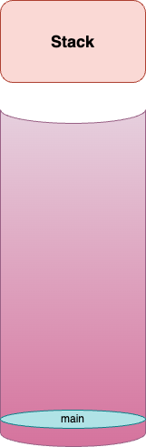

**Step 2:**

Inside the Main() function, the first function was called which is function1().

public static void main (String[] args){

int arr[] = {1,2,3,4,5};

function1(arr, 4) ;

function2();}

**The stack contains:**

Function1(arr, 4).

Main().

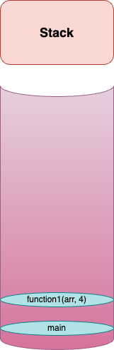

**Step 3:**

Inside the function1() there is a condition which is i<0 and in this step i=4 so it will go to the else condition so the function one will be called again but now with I-1.

**The stack contains:**

Function1(arr, 3).

Function1(arr, 4).

Main().

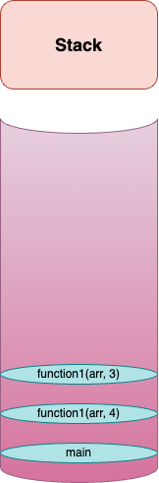

**Step 4:**

The recursive will call the function1() again, inside the function1() there is a condition which is i<0 and in this step i=4 so it will go to the else condition so the function one will be called again but now with I-1.

**The stack contains:**

Function1(arr, 2).

Function1(arr, 3).

Function1(arr, 4).

Main().

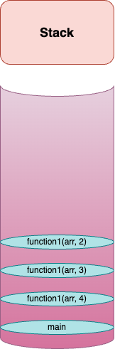

**Step 5:**

The recursive will call the function1() again, inside the function1() there is a condition which is i<0 and in this step i=2 so it will go to the else condition so the function one will be called again but now with I-1.

**The stack contains:**

Function1(arr, 1).

Function1(arr, 2).

Function1(arr, 3).

Function1(arr, 4).

Main().

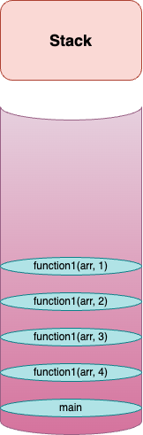

**Step 6:**

The recursive will call the function1() again, inside the function1() there is a condition which is i<0 and in this step i=1 so it will go to the else condition so the function one will be called again but now with I-1.

**The stack contains:**

Function1(arr, 0).

Function1(arr, 1).

Function1(arr, 2).

Function1(arr, 3).

Function1(arr, 4).

Main().

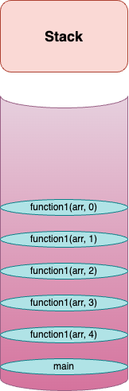

**Step 7:**

The recursive will call the function1() again, inside the function1() there is a condition which is i<0 and in this step i=0 so it will go to the else condition so the function one will be called again but now with I-1.

**The stack contains:**

Function1(arr, -1).

Function1(arr, 0).

Function1(arr, 1).

Function1(arr, 2).

Function1(arr, 3).

Function1(arr, 4).

Main().

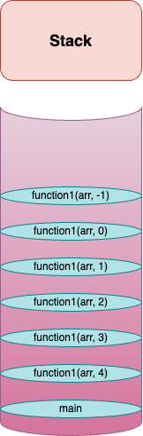

**Step 8:**

Finally, the condition is true which means i = -1 and the condition says that I must be less than 0.

So function2() will be called.

**The stack contains:**

Function2().

Function1(arr, -1).

Function1(arr, 0).

Function1(arr, 1).

Function1(arr, 2).

Function1(arr, 3).

Function1(arr, 4).

Main().

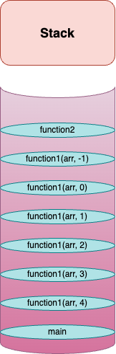

**Until here all the functions that are in the stack are paused:**

**In the next step the functions that are in the stack starts to execute one by one.**

**Step 9:**

Function2() will print “let’s start” and then it will be executed (completed) which means it will leave the stack.

**The stack contains:**

Function1(arr, -1).

Function1(arr, 0).

Function1(arr, 1).

Function1(arr, 2).

Function1(arr, 3).

Function1(arr, 4).

Main().



**Outcomes:**

"lets start ^_^"

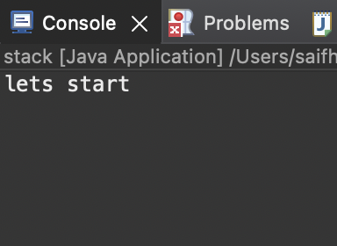

**Step 10:**

Function1(arr, -1) will go to the if statement and inside the if statement there is function2() and it is already executed so function1(arr, -1) will be finished and it will leave the stack.

**The stack contains:**

Function1(arr, 0).

Function1(arr, 1).

Function1(arr, 2).

Function1(arr, 3).

Function1(arr, 4).

Main().



**Outcomes:**

"lets start ^_^"

**Step 11:**

Function1(arr, 0) will go to the else statement which is inside function1, and will print the element that has the index 0 in the array that is provided as arr, and the function1(arr, 0) leaves the stack.

**The stack contains:**

Function1(arr, 1).

Function1(arr, 2).

Function1(arr, 3).

Function1(arr, 4).

Main().



**Outcomes:**

"lets start ^_^"

1

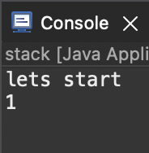

**Step 12:**

Function1(arr, 1) will go to the else statement which is inside function1 and will print the element that has the index 1 in the array that is provided as arr, and the function1(arr, 1) leaves the stack.

**The stack contains:**

Function1(arr, 2).

Function1(arr, 3).

Function1(arr, 4).

Main().



**Outcomes:**

"lets start ^_^"

1

2

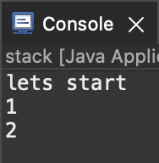

**Step 13:**

Function1(arr, 2) will go to the else statement which is inside function1 and will print the element that has the index 2 in the array that is provided as arr, and the function1(arr, 2) leaves the stack.

**The stack contains:**

Function1(arr, 3).

Function1(arr, 4).

Main().



**Outcomes:**

"lets start ^_^"

1

2

3

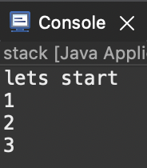

**Step 14:**

Function1(arr, 3) will go to the else statement which is inside function1 and will print the element that has the index 3 in the array that is provided as arr, and the function1(arr, 3) leaves the stack.

**The stack contains:**

Function1(arr, 4).

Main().



**Outcomes:**

"lets start ^_^"

1

2

3

4

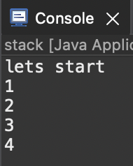

**Step 15:**

Function1(arr, 4) will go to the else statement which is inside function1 and will print the element that has the index 4 in the array that is provided as arr, and the function1(arr, 4) leaves the stack.

**The stack contains:**

Main().



**Outcomes:**

"lets start ^_^"

1

2

3

4

5

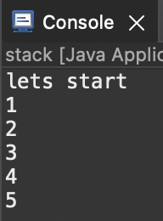

**Step 16:**

Inside the Main() function, the second function will be called which is function2().

**The stack contains:**

Function2().

Main().

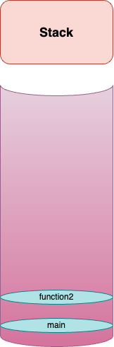

**Outcomes:**

"lets start ^_^"

1

2

3

4

5

**Step 17:**

Inside the function2(), will print “let’s start” and then it will be executed (completed) which means it will leave the stack.

**The stack contains:**

Main().



**Outcomes:**

"lets start ^_^"

1

2

3

4

5

"lets start ^_^"

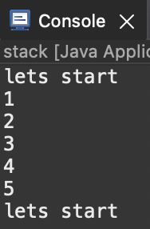

**Step 18:**

No functions are left in the main function, which means the Main function is completed and it will leave the stack.

**The stack contains:**

Nothing left it is empty.

**Outcomes:**

"lets start ^_^"

1

2

3

4

5

"lets start ^_^"

**In conclusion:**

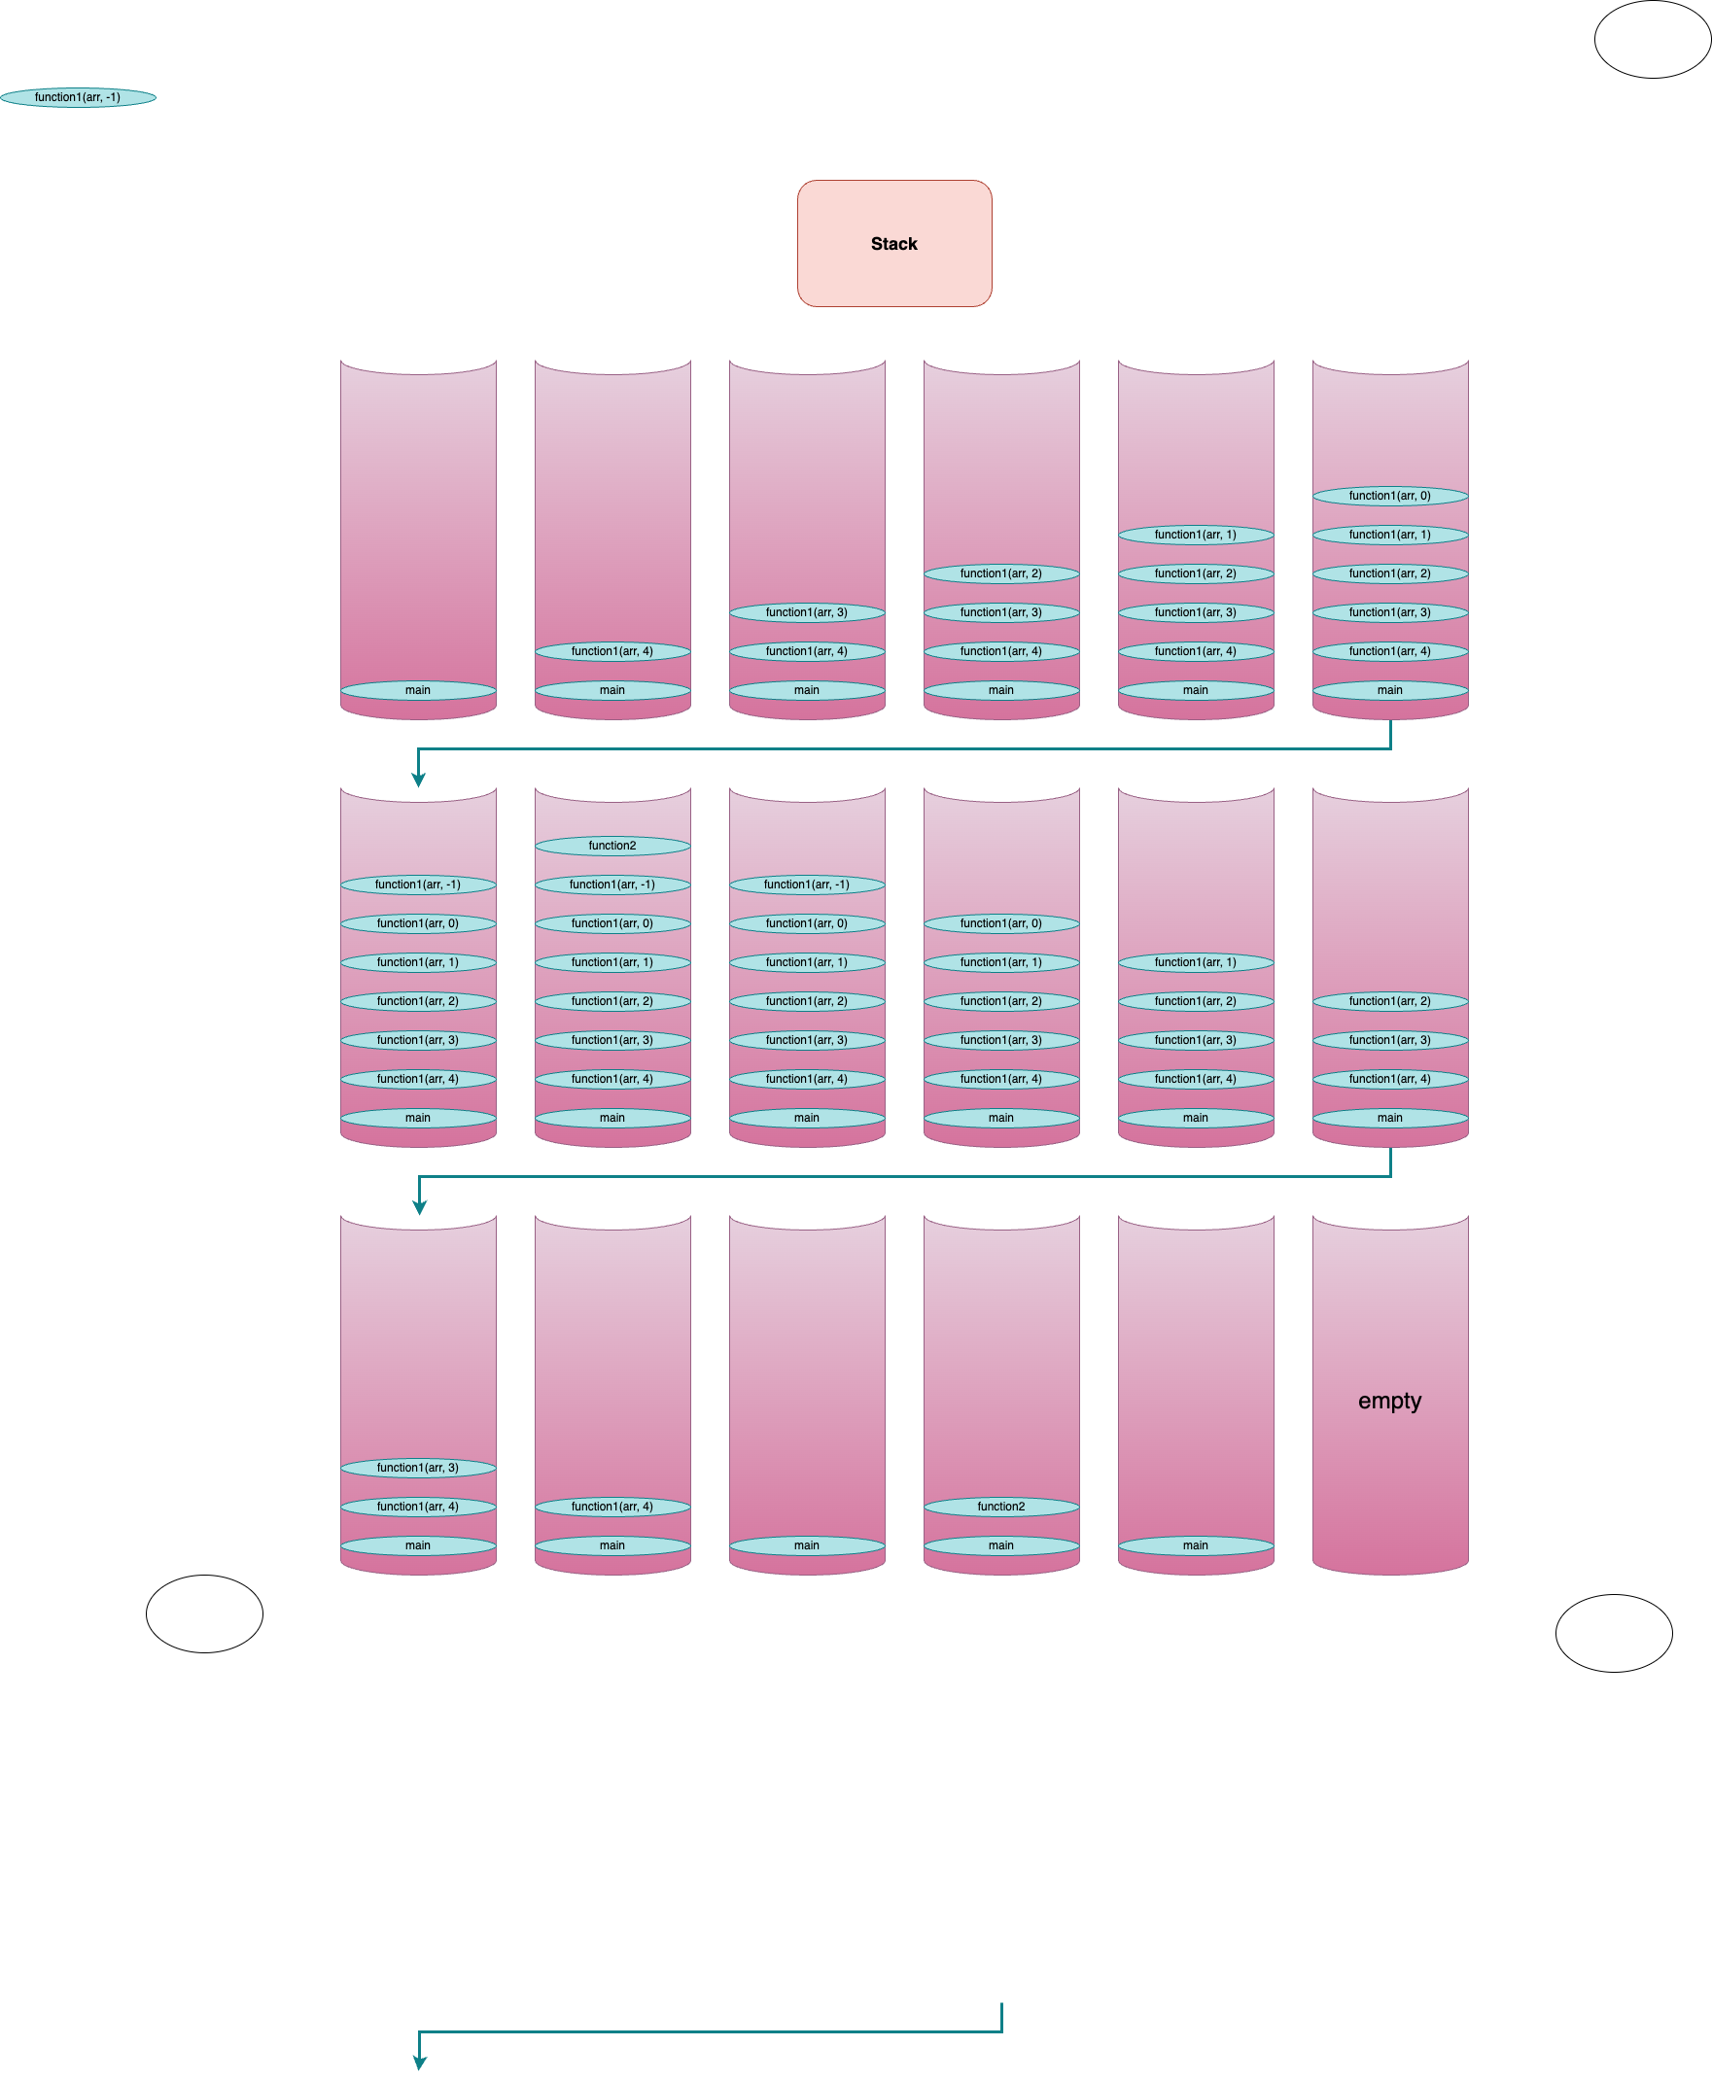

**Part 4:**

|  |  |  |  |
| --- | --- | --- | --- |
|  | **Linked List** | **Array unsorted** | **Array sorted** |
| **Search** | O(n)  Because it uses linear search algorithm  (codingninjas, 2022)  (Forcha, 1969) | O(n)  Because it uses linear search algorithm  (Aguilar, 2019) (GeeksforGeeks, 2023) | O(n)  Because it uses a linear search algorithm.  O(log n)  Because it uses a binary search algorithm.  (GeeksforGeeks, 2022) |
| **Insert** | O(n) insert at a position  Because we will need to traverse until we arrive at the position.  (codingninjas, 2022)  (Forcha, 1969) | O(n) insert at position  because we will need to shift the elements.  (Aguilar, 2019) (GeeksforGeeks, 2023) | O(n) insert at a position  Because elements must be moved in order to keep the sorted order.  (GeeksforGeeks, 2022) |
| **Remove** | O(n) remove at a position  Because we will need to traverse until we arrive at the position.  (codingninjas, 2022)  (Forcha, 1969) | O(n) remove at a position  because we will need to shift the elements  (Aguilar, 2019) (GeeksforGeeks, 2023) | O(n) remove at a position  Because elements must be moved in order to keep the sorted order.  (GeeksforGeeks, 2022) |

**Linked List:**

**1-Search:** In a linked list, you must start at the head and work your way down through each element until you get to locate the one you're looking for or reach the list's end. As a result, in the worst case, it would take O(n) time to iterate through n items.

(codingninjas, 2022) (Forcha, 1969)

**2-Insert at position:** You must first identify the location in the linked list where you want to put a new entry. This requires beginning at the head of the list and moving down iteratively until you reach the location where you want to place the new value in it, with an O(n) time complexity. (codingninjas, 2022) (Forcha, 1969)

**3-Remove at position:** Similar to insertion, the first step in removing an element from a certain place is to traverse the linked list to locate that point, which will take O(n). (

codingninjas, 2022) (Forcha, 1969)

**Array unsorted:**

**1-Search**: In the worst scenario, looking for a single element in an unsorted array would require scanning every element in the array until you found the value that i want, which will have an O(n) time complexity.

(Aguilar, 2019) (GeeksforGeeks, 2023)

**2-Insert:** To make a place for a new element when you want to put one at a certain location inside an unsorted array, you must move all items after that location. In the worst situation, this shifting operation needs traversing over n items, giving it an O(n) time complexity.

(Aguilar, 2019) (GeeksforGeeks, 2023)

**3-Remove:** To delete an element from a certain location in an array, all items following that place must be relocated in order to fill the empty space left by the deleted element. In the worst scenario, this necessitates running over n items once again, resulting in an O(n) time complexity. (Aguilar, 2019) (GeeksforGeeks, 2023)

**Array sorted:**

**1-Search:**

**If a liner search algorithm is used:** if we want to search for an element the time complexity will be O(n) because it will start checking element by element until we found the element that we want it, also in the worst case if the element is in the end of the array or it is not in the array this algorithm will go through all the elements which will take O(n) depends on the number of the elements that are in the array.

(GeeksforGeeks, 2022)

**If a binary search algorithm is used:** works by splitting the array in half around the center element, then comparing that element to the required value. The search moves on to the right side of the array if the center element is smaller than the goal; otherwise, it moves on to the left. The sub-array decreases to zero or the target value is reached before the division stops. As a result, because we continuously divide the array in half until we discover the target, the time complexity is O(log n).

(GeeksforGeeks, 2022)

**2-Insert:** In order to keep the array's sorted order, you must choose where the new element should fit. In order to create place for the new element after you find the right location, you might need to move all elements that come after it. The complexity of time is O(n) since, in the worst situation, you could need to move all the elements.

(GeeksforGeeks, 2022)

**3-Remove:** The element must first be located (using a binary search, this may be done in O(log n) time), after which any elements following it may need to be shifted in order to fill the space left by the element's removal. O(n) is the time complexity.

(GeeksforGeeks, 2022)

**Q14)**

**First scenario:**

Spell checker application. The data structure is used to store a dictionary of words. The data structure is constructed so that each node contains a word. When a user types a word, the spell checker searches for that word. If the word is found, it is considered spelled correctly. If the word is not found, the spell checker can suggest a list of words that are similar in spelling to the word that was typed, by searching for words that are similar in their prefix.

**Chosen data structure:** Sorted array data structure.

**Justification:**

**Why I Choose Sorted Array:**

**1-** **Fast Search:** We can look up words in a Sorted Array by using binary search which effects in a significant increment in speed. Comparing this to the linear search that we use in a linked list or in the unsorted array, A Sorted Array would enable quicker word lookup for the spell checker application because binary search has an O(log n) time complexity.

(Wiki, 2023) (GeeksforGeeks, 2023) (twodayslatetwodayslate 26211 gold badge44 silver badges1313 bronze badges et al., 1955) (twodayslatetwodayslate 26211 gold badge44 silver badges1313 bronze badges et al., 1955) (Quora, 2022) (Robinson, 2023) (alibabacloud)

**2-Searching based on spelling and prefix:** In a sorted array, prefix-based search is achievable by using the binary search algorithm. When the term isn't in the dictionary, you may offer spelling recommendations by giving words that are similar in spelling or close to it in the sorted array.

(Wiki, 2023) (GeeksforGeeks, 2023) (twodayslatetwodayslate 26211 gold badge44 silver badges1313 bronze badges et al., 1955) (twodayslatetwodayslate 26211 gold badge44 silver badges1313 bronze badges et al., 1955) (Quora, 2022) (Robinson, 2023) (alibabacloud)

**3-Memory usage:** Arrays often use less memory than linked lists do. This is because linked lists need additional storage for references to each element. If your word dictionary is large, so it's an important point to take into mind.

(Wiki, 2023) (GeeksforGeeks, 2023) (twodayslatetwodayslate 26211 gold badge44 silver badges1313 bronze badges et al., 1955) (Quora, 2022) (Robinson, 2023) (alibabacloud)

**Why I did not choose the Linked list:**

**1-Slow Search:** To find the requested element in a Linked List, the complete list must be scanned. This linear search process is much slower than binary search in a Sorted Array

(GeeksforGeeks, 2023) (twodayslatetwodayslate 26211 gold badge44 silver badges1313 bronze badges et al., 1955)

**2-** **Ineffective Memory Use:** Compared to arrays, linked lists are less memory-efficient because they need extra space to save the pointers linking each element to the following one.

(GeeksforGeeks, 2023) (twodayslatetwodayslate 26211 gold badge44 silver badges1313 bronze badges et al., 1955)

**Why I did not Choose Unsorted Array:**

**1-Slow Search:** An Unsorted Array would need a linear search to locate elements, similar to the Linked List. Compared to binary search in a Sorted Array, the unsorted takes more time to complete**.**

(twodayslatetwodayslate 26211 gold badge44 silver badges1313 bronze badges et al., 1955) (Quora, 2022) (Robinson, 2023) (alibabacloud)

**2-Difficulty of spelling and prefix-based Suggestions:** In an Unsorted Array, it would be more challenging to provide prefix-based spelling recommendations. This is a less effective option since the array would need to be sorted before any useful suggestions could be given.

(twodayslatetwodayslate 26211 gold badge44 silver badges1313 bronze badges et al., 1955) (Quora, 2022) (Robinson, 2023) (alibabacloud)

|  |  |  |  |
| --- | --- | --- | --- |
|  | **Linked List** | **Unsorted Array** | **Sorted Array** |
| **Search Speed** | Slow | Slow | Fast |
| **Spelling and prefix-based Suggestions** | difficult | difficult | Easy |
| **Memory Use** | Less efficient | More efficient | More efficient |

**Note:** from the three given data structures the Sorted Array is the best.

**Second scenario:**

Priority queues. The data structure can be used to implement priority queues efficiently. It should allow for efficient insertion and deletion operations.

**Chosen data structure:** Linked List.

**Justification:**

**Why I Choose Linked List:**

**1-Efficient Insertion at any Position:** A Linked List must first be traversed in order to locate the location you want before you can put an element there. This process takes O(n) time. However, the actual insertion is pretty successful after you've found the perfect location. You just need to do an O(1) operation to modify the pointers node of the next nodes. But The insertion process takes longer in both array types (Sorted or Unsorted) than it does in a linked list on average. In order to insert an element anywhere in the center of an array since it is a continuous block of memory, the following items must be moved, which requires a lot of computation for shifting.

(Krohn, 2019) (Sharma, 2023) (twodayslatetwodayslate 26211 gold badge44 silver badges1313 bronze badges et al., 1955)

**2-** **Efficient Deletion at Position:** In a Linked List, after we arrive at the place that we want based on the priority, we may easily do a deletion operation (O(1) time) by changing the pointers.

(Krohn, 2019) (Sharma, 2023) (twodayslatetwodayslate 26211 gold badge44 silver badges1313 bronze badges et al., 1955)

**Why I did not choose the Sorted Array or Unsorted Array:**

**1-** **Inefficient Insertion and Deletion at Position:** For insertion or deletion at a specified location in both an Unsorted Array and a Sorted Array, items must be moved in order to fill the empty space (for deletion) or create space for a new element (for insertion). An array is less effective than a linked list for these operations because the shifting operation has an O(n) time complexity.

(Krohn, 2019) (Sharma, 2023) (twodayslatetwodayslate 26211 gold badge44 silver badges1313 bronze badges et al., 1955)

|  |  |  |  |
| --- | --- | --- | --- |
|  | **Linked List** | **Unsorted Array** | **Sorted Array** |
| **Insertion at Position** | Efficient O(n) to find position, O(1) to insert) | Less efficient | Less efficient |
| **Deletion at Position** | Efficient O(n) to find position, O(1) to delete) | Less efficient | Less efficient |

**Q15)**

public static int fun1(int [] arr, int index)

{

if (index<=0)

{

return arr[0];

}

int m1 = fun1(arr, index-1);

int m2 = fun1(arr, index-2) ;

int m3 = fun1(arr, index-4) ;

if (m1>m2)

{

return m1;

}

else if (m2>m3)

{

return m3;

}

else

{

return m1;

}

}

**What is this function:**

This function, which is recursive, determines which of three array elements has the highest value. Based on the numbers in index-1, index-2, and index-4, the elements are chosen.

**Time complexity:**

A function's running time is often calculated based on the number of operations it does, which typically depends on the input's size. The total time for recursive functions is the sum of the times that each recursive call happens.

The function runs itself three times on each recursive step, using the parameters index-1, index-2, and index-4.

The function does constant work (returns the array's zeroth element) when n is less than zero. With n = 0, T(n) equals O(1).

When n is greater than 0, the function recursively runs itself three times, taking as arguments, respectively, n-1, n-2, and n-4. T(n) is therefore equal to T(n-1) + T(n-2) + T(n-4).

The whole period required for an input size of n is T(n).

The O(1) in the base case.

So the time complexity of this code is O(3^n)

**This function's recurrence relation may be written as follows:**

T(n) = T(n-1) + T(n-2) + T(n-4), for n > 0

T(n) = O(1), for n <= 0

**How I did calculate the time complexity:**

**Step 1:**

**I understood the function:** It is a recursive function that accepts an array and an index as argument. For each non-base scenario, it makes three calls to itself: once with index-1, once with index-2, and once with index-4. This indicates that the function divides into three parts during each recursive call, with the exception of when index = 0, in which case it simply returns arr[0].

**Step 2:**

**Base case and recursive case:** The function's base case is when index = 0, and because it performs an unchanged value of work (returning arr[0]), it has an O(1) time complexity. When index is greater than 0, there are three additional recursive calls, which is the recursive case. As a result, the function's time complexity when n > 0 may be described as the sum of the times the function takes for n-1, n-2, and n-4.

**Step 3:**

**Establishing the relationship of recurrence**: The observations made above allow us to create a recurrence relation for the function's temporal complexity. It is possible to represent the temporal complexity of a function in terms of smaller inputs using this mathematical equation. We get the following results for this function: T(n) = O(1) for n = 0 and T(n) = T(n-1) + T(n-2) + T(n-4) for n > 0.

**Step 4:**

**Recurrence relation interpretation:** The time complexity of the equation for a given input size n is equal to the sum of the time complexities for input sizes n-1, n-2, and n-4, according to the recurrence relation. This shows that the time complexity of the function increases with each increase in n, and that this increase is further increased by the reality that every recursive call splits into three further calls.

**Step 5:**

**Calculating the total time complexity:**we may estimate it simply. The complexity of time may be calculated as O(3n) since every recursive call split into three, and this splitting occurs with each increase in n.

**More details:**

A new level of recursion is added for each increase in n. The branching factor is divided by the whole amount of function calls at each level of recursion. Consequently, the branching factor increased to the power of the number of layers of recursion may be thought of as the overall quantity of function calls and the time complexity.

The value of the exponent is n (the input size), and the base of the expansion is the splitting factor, which in this example is 3. As a result, we get an O(3n) time complexity.

The exponential time complexity is O(3n). This implies that the function's execution time will treble for any little increase in n. Because of how quickly the execution time grows for big inputs, the function is resulting in very inefficient. It is possible that the function will take three times longer to run if n is a little higher.

**Q16)**

**The advantages of encapsulation:**

**Easy to Use:**

The use of data structures becomes easier by encapsulation. Users just need to be aware of the available operations; they don't have to be aware of the specifics of implementation.

(GeeksforGeeks, 2023) (eBooks Library, 2022) (Encapsulation and abstract data, 2022)

**Reuse:**

Encapsulated data structures can be used repeatedly inside a single program or among several applications.

(GeeksforGeeks, 2023) (eBooks Library, 2022) (Encapsulation and abstract data, 2022)

**Security:**

Data security is achieved via information hiding, which stops illegal access and data modification.

(GeeksforGeeks, 2023) (eBooks Library, 2022) (Encapsulation and abstract data, 2022)

**Easy to update:**

Because of encapsulation, changes to the data structure's basic implementation may be made without having an impact on the code that utilizes it.

(GeeksforGeeks, 2023) (eBooks Library, 2022) (Encapsulation and abstract data, 2022)

**Prevents unexpected problems:**

Encapsulation protects against accidental changes that might introduce issues or unwanted side effects by hiding a data structure's internal workings.

(GeeksforGeeks, 2023) (eBooks Library, 2022) (Encapsulation and abstract data, 2022)

**Data Integrity:**

We can limit who can access or change data by hiding a data structure's internal workings. For example, when adding or removing pieces from a stack, only the top of the stack should be changed. The integrity of the data is protected since we are sure that this rule is always accomplished by encapsulating this functionality.

(GeeksforGeeks, 2023) (eBooks Library, 2022) (Encapsulation and abstract data, 2022)

|  |  |  |  |
| --- | --- | --- | --- |
|  | **Explanation** | | |
| **Advantages** | **Stack** | **Queue** | **Linked List** |
| **Easy to Use:** | Users do not need to understand what's inside the list or array structure; only the push and pop actions are required. | Users don't need to understand the specifics of how data stores, just the enqueue and dequeue actions. | Users do not need to understand the pointers that join the nodes; they simply need to know how to add and delete nodes. |
| **Reuse:** | Once defined, the stack data structure may be used in any situation where a stack is needed. | The queue data structure provides reused in many different kinds of situations. | The linked list data structure may be applied to a variety of situations, such as building a navigation system or a playlist of music. |
| **Security:** | Data security is preserved since users are unable to directly change the stack's foundational information. | The fundamental data of the queue cannot be directly accessed or changed. | It is impossible to directly change the pointers between nodes, which improves security. |
| **Easy to update:** | It is possible to switch from a list to a linked list as the internal data storage format, for example, without having any negative effects on users. | The Queue's internal data structure is changed without affecting the enqueue and dequeue actions. | The linked list code could be managed and changed without impacting the internal references. |
| **Prevents unexpected problems:** | Users cannot access or mistakenly modify the order of items, which prevents issues. | Users cannot mistakenly delete an element from the queue that is not first, which prevent possible mistakes. | Users cannot accidentally edit the pointers, which can disconnect nodes and cause the list to fail. |
| **Data Integrity:** | The integrity of the data is protected by allowing access and removal only to the most recent element. | The only piece that may be accessed and removed is the one at the head of the queue. | Only specific operations can be used to change or delete data from a node. |

(GeeksforGeeks, 2023)

**Q17)**.

**Do you agree that imperative ADTs are a basis for object orientation?**

Yes, I agree.

**Here is how (Justification):**

**1-** **Encapsulation:**

Bundling data and processes (operations) into one entity is one of the core concepts of ADTs. Encapsulation is the term used for this. Data in ADTs stays hidden from the public view and is accessible only through a specific set of operations. This idea is immediately adopted by OOP, where it is improved. In OOP, an object encapsulates either data and the functions that operate on that data, offering a more efficient implementation of encapsulation.

(utexas, 2022) (Cook, 1991) (Sheldon, 2022)

**Going more in detail:**

Encapsulation is a key idea used in Object-Oriented Programming (OOP) that was derived from Abstract Data Types (ADTs).

Encapsulation is the concept that the user only interacts with a data type through a certain number of operations and that the fundamental operations involved in the data type are kept secret from the user in the context of ADTs. It's similar to a "box" where you can move it or through (using the operations) but can't see or directly change what's inside.

when this idea is applied to OOP It became used into the concept of an "object" In object-oriented programming (OOP), attributes and the methods that modify it are encapsulated. It is not necessary for the user of the object to be aware of the specifics of how these methods happen or how the data is saved. All they need to know is how to use every method and what options are available.

Therefore, the encapsulation idea from ADTs is basically a modification and application of the encapsulation concept in OOP. Additionally, it improves the organization and reuse of the code while helping in ensuring that data is tied securely within objects.

(utexas, 2022) (Cook, 1991) (Sheldon, 2022)

**2-** **Data Abstraction:**

ADTs introduced the concept of data abstraction, when a user may interact with a data type through a specified interface without needing to understand how it operates inside. OOP develops this idea more. Classes in OOP specify how data from an object is accessed. The opportunities of data abstraction are increased over what ADTs can provide because to this abstraction mechanism, which allows complex structures and connections between objects.

(utexas, 2022) (Cook, 1991) (Sheldon, 2022)

**Going more in detail:**

Data abstraction, as used in ADTs, relates to the idea that we can create a new data type (such as a list, stack, or queue) and state the operations that can be carried out on it without needing to understand or be worried about the way these operations are implemented. This makes it possible for us to use the ADT simply, relying on what it does instead of how it does it.

This idea is carried on in OOP, where it is developed more. An abstract interface in OOP is provided by a class, which serves as an object's blueprint. A collection of methods that may be used by an object of that class forms this interface. You do not need to be familiar with the implementation of these methods in order to build an object from a class. Just be aware of what they do.

Because of the abstraction of data and actions, programmers may create simpler and reliable code. Without getting caught down in the specifics of how those things function inside, they may use existing objects and build new ones. In the end, OOP has expanded the idea of data abstraction from ADTs and made it a central component of the way it creates and organizes code.

(utexas, 2022) (Cook, 1991) (Sheldon, 2022)

**3-** **Mutable State:**

The fundamental principle of imperative programming, mutable state, is shared by ADTs and OOP. Operations in ADTs can change the status of the data type. OOP allows for the state of an object to be changed through methods. This idea serves as the foundation for how OOP has developed and expanded the concept of state change in ADTs.

(utexas, 2022) (Cook, 1991) (Sheldon, 2022)

**Going more in detail:**

Another fundamental idea that has been included in Object-Oriented Programming (OOP) from Abstract Data Types (ADTs) is the idea of a mutable state.

Through the described operations in ADTs, the state of the data type may be changed. For example, you may add or remove items from a list ADT if there is one. These procedures change the list's state; it is not the same list post-operation as it was before.

This idea is immediately applied to OOP. An object's state is defined by its attributes in OOP, and these attributes may be changed through methods. Think of a car item as an example. Car objects could have attributes such as color and speed. These methods, which include setColor() and increase speed (), may modify the current state of the Car object. The color of the Car has changed after the procedure setColor("red") was called.

The idea of changing an object's state in OOP is derived from ADTs' mutable state. Imperative programming is based on the concept of mutable states, where the program's state changes over time. It is an essential component that enables either ADTs and OOP to represent and solve challenging programming issues.

(utexas, 2022) (Cook, 1991) (Sheldon, 2022)

**4-** **Extension to OOP Features:**

OOP adds some features like inheritance, polymorphism, and classes to the ADT ideas. The functionality of existing objects may be expanded, and code can be reused, because of inheritance. Because of polymorphism, there is greater freedom in function names when comparing different ADTs because the same action might behave differently depending on the object it is working against. The idea of producing instances in ADTs is extended to classes, which serve as templates for constructing things.

(utexas, 2022) (Cook, 1991) (Sheldon, 2022)

**Going more in detail:**

The foundational ideas of Object-Oriented Programming (OOP), such as inheritance and polymorphism, are not directly derived from Abstract Data Types (ADTs). However, they are formal extensions of the ADTs' fundamental principles.

We focus on creating a data type and the operations that may be done on that data in ADTs. When we go to OOP, we expand on this concept by creating classes, which serve as the building blocks for objects. Both data attributes and methods) may be present in these objects.

OOP's idea of inheritance enables a class to take on all the characteristics and functions of another class. Although it isn't an ADT feature, we might say that it is an extension of a concept of reusing and extending pre-existing types, which is an essential component of ADTs.

OOP's use of polymorphism makes it possible to handle many types of objects effectively. Even while this isn't a direct characteristic of ADTs, it is consistent with the ADT concept of abstraction—we focus on the operations that can be carried out rather than the particular types we're working with.

Although inheritance and polymorphism don't directly take features from ADTs, they do build on their fundamental concepts. They show how these ideas have grown and evolved as we go from ADTs to a more flexible and adaptive OOP paradigm.

(utexas, 2022) (Cook, 1991) (Sheldon, 2022)

**Q18):**

**What do we mean by implementation-dependent for the Array and the Linked List:**

**1-** **Format for Memory:**

Linked lists are made up of individual nodes that spread throughout memory and contain data and a pointer to the next node, as compared to arrays, which need just one continuous block of memory. The memory management of the system affects these specifics.

**2-** **Flexibility in size:**

Linked lists are sized dynamically, while arrays has a fixed size. The way size changes are handled depends on the operating system you're using.

**3-** **Access Techniques:**

In contrast to linked lists, which must be traversed from the list's beginning to the requested entry, arrays provide immediate access by index. This difference shows that each data structure will require a different amount of time and resources.

**What do we mean by implementation-independent for the Stack and the Queue:**

**1-** **Operating Abstractly:**

Instead of how these operations are implemented, stacks and queues are described by their operations (enqueue/dequeue for queues and push/pop for stacks).

**2-** **Flexible Implementation:**

You can use an array, a linked list, or another data structure to create a stack or a queue. The abstract operations are unaffected by the fundamental structure.

**3-** **Interface consistency:**

The stack or queue's operations are unchanged regardless of the implementation used below. This means that if the fundamental implementation changes, the code that uses a stack or queue won't need to be changed.

**The benefits of using implementation-independent data structures:**

**1-** **Portable:**

It is incredibly advantageous because these data structures may be used in a variety of systems and languages. Avoiding the need to rewrite the same code for many platforms, can assist save a lot of time and effort.

(Data Structures, 2022) (Toru, 2022)

**2-** **Standardized Operations:**

Using standardized operations makes the code more readable and clear. Developers can use data structures without having to understand their fundamental workings. This not only helps with code maintenance but also makes it easier for other developers to understand and apply the code. A team can work more effectively and reduce the risk of mistakes based on how simple the code is to understand.

(Data Structures, 2022) (Toru, 2022)

**3-** **Separation and encapsulation:**

Separation is the process of separating a data structure's fundamental operations from how it communicates with other software components. That means that you may modify the way the data structure is implemented without having an impact on the rest of the application. This basic idea of software development makes it possible to write code that is easier to manage and maintain. Software systems become flexible and adjustable, which makes it simpler to upgrade or change them without having a negative impact.

(Data Structures, 2022) (Toru, 2022)

**Evaluating these benefits:**

**1-** **Portable:**

Stacks and queues are easily portable because of their implementation independence, which is very advantageous when an application needs to be implemented across many platforms or systems. Because of the portability, development time decreases down and any mistakes caused by system-specific implementation details are reduced. The ease of use of the application solution is increased by the interoperability, which also ensures easy interaction with other software systems.

(Data Structures, 2022) (Toru, 2022)

**2-** **Standardized Operations:**

Regardless of how they are actually implemented, stacks and queues offer a clear and standardized interface for operations. Offering a common set of operations, simplifies the learning curve for technologists new to the project, improves the accessibility of the code, and helps with debugging. These standardized processes provide clarity to the code structure, which may significantly reduce mistakes.

(Data Structures, 2022) (Toru, 2022)

**3-** **Separation and encapsulation:**

The encapsulation of data in stacks and queues, which facilitates the division of user interface from implementation, gives developers more control over the code update operation. The risk connected with code changes is decreased since modifications to the implementation of those data structures won't result in an error in the current code. It enables a more flexible, powerful, and easy codebase, which results in improved reliability and successful software development processes, and efficiency.

(Data Structures, 2022) (Toru, 2022)

**Part 1:**

Priority queue, P. queue (2017) *Priority queue introduction*, *YouTube*. Available at: https://www.youtube.com/watch?v=wptevk0bshY (Accessed: 13 May 2023).

Priority queues, engineering (2022) *Priority queues - computer & information science & engineering*. Available at: https://www.cise.ufl.edu/~sahni/cop3530/slides/lec236.pdf (Accessed: 14 May 2023).

Java Priority Queue, J.P.Q. (2023) *Java Priority Queue tutorial - implementation & examples*, *Software Testing Help*. Available at: https://www.softwaretestinghelp.com/java-priority-queue-tutorial/ (Accessed: 15 May 2023).

great learning, great learning (2021) *Priority queue in data structure | queue vs priority queue |data structure tutorial | great learning*, *YouTube*. Available at: https://www.youtube.com/watch?v=YDo65gKDRPo&t=474s (Accessed: 15 May 2023).

queue implementation, queue implementation (2022) *Priority queue implementation with linked list*, *YouTube*. Available at: https://www.youtube.com/watch?v=sc_A9uo8S2E&t=299s (Accessed: 15 May 2023).

Priority queue using linked list, P. queue using linked list (2023) *Priority queue using linked list*, *GeeksforGeeks*. Available at: https://www.geeksforgeeks.org/priority-queue-using-linked-list/ (Accessed: 15 May 2023).

codingninjas, codingninjas (2022) *Code studio*. Available at: https://www.codingninjas.com/codestudio/library/applications-of-priority-queue (Accessed: 16 May 2023).

Alipour-Vaezi, M., Aghsami, A. and Jolai, F. (2022) *Prioritizing and queueing the emergency departments’ patients using a novel data-driven decision-making methodology, a real case study*, *Expert systems with applications*. Available at: https://www.ncbi.nlm.nih.gov/pmc/articles/PMC8800569/ (Accessed: 16 May 2023).

Applications of priority queue, A. of priority queue (2023) *Applications of priority queue*, *GeeksforGeeks*. Available at: https://www.geeksforgeeks.org/applications-priority-queue/ (Accessed: 16 May 2023).

datatrained, datatrained (2023) *Time complexity of sorting algorithms | datatrained*. Available at: https://www.datatrained.com/post/time-complexity-of-sorting-algorithms/ (Accessed: 04 June 2023).

**Part 3:**

ASCII, A. (2022) *ASCII - binary character table*. Available at: http://sticksandstones.kstrom.com/appen.html (Accessed: 18 May 2023).

S, R.A. (2023) *Arrays in data structure: A guide with examples [updated]*, *Simplilearn.com*. Available at: https://www.simplilearn.com/tutorials/data-structure-tutorial/arrays-in-data-structure#:~:text=DevelopmentExplore%20Program-,What%20Are%20Arrays%20in%20Data%20Structures%3F,the%20size%20of%20the%20array. (Accessed: 17 May 2023).

Data Structures, D.S. (2022) *Data Structures and algorithms - arrays*, *Tutorials Point*. Available at: https://www.tutorialspoint.com/data_structures_algorithms/array_data_structure.htm#:~:text=The%20basic%20operations%20in%20the,the%20status%20of%20the%20array. (Accessed: 17 May 2023).

array, array (2022) *What is an array? definition and introduction (with faqs)*. Available at: https://www.indeed.com/career-advice/career-development/what-is-array (Accessed: 17 May 2023).

**Part 4:**

codingninjas, codingninjas (2022) *Code studio*. Available at: https://www.codingninjas.com/codestudio/library/time-and-space-complexity-of-linear-data-structures#:~:text=below%20complexity%20analysis.-,Time%20Complexity%20of%20linked%20list%20storing%20’N’%20elements,by%20traversing%20the%20linked%20list. (Accessed: 01 June 2023).

Forcha, C. (1969) *Linked list time complexity*. Available at: https://linuxhint.com/linked-list-operations-time-complexity/ (Accessed: 01 June 2023).

Aguilar, L. (2019) *Search algorithm: Front and back (unsorted)*, *Medium*. Available at: https://medium.com/@insomniocode/search-algorithm-front-and-back-unsorted-86d7a4bfc258#:~:text=The%20most%20common%20algorithm%20to,takes%20O(n)%20complexity. (Accessed: 01 June 2023).

GeeksforGeeks, G. (2023) *How to search, insert, and delete in an unsorted array:*, *GeeksforGeeks*. Available at: https://www.geeksforgeeks.org/search-insert-and-delete-in-an-unsorted-array/ (Accessed: 01 June 2023).

GeeksforGeeks, G. (2022) *Search, insert and delete in a sorted array*, *GeeksforGeeks*. Available at: https://www.geeksforgeeks.org/search-insert-and-delete-in-a-sorted-array/ (Accessed: 01 June 2023).

Wiki, W. (2023) *Sorted array*, *Wikipedia*. Available at: https://en.wikipedia.org/wiki/Sorted_array (Accessed: 01 June 2023).

GeeksforGeeks, G. (2023b) *Linked list vs array*, *GeeksforGeeks*. Available at: https://www.geeksforgeeks.org/linked-list-vs-array/ (Accessed: 01 June 2023).

twodayslatetwodayslate                    26211 gold badge44 silver badges1313 bronze badges *et al.* (1955) *Feasibility of LinkedList vs. array for sorted vs. unsorted data?*, *Stack Overflow*. Available at: https://stackoverflow.com/questions/276278/feasibility-of-linkedlist-vs-array-for-sorted-vs-unsorted-data (Accessed: 01 June 2023).

Robinson, S. (2023) *Why is processing a sorted array faster than processing an unsorted array?*, *Stack Abuse*. Available at: https://stackabuse.com/bytes/why-is-processing-a-sorted-array-faster-than-processing-an-unsorted-array/ (Accessed: 01 June 2023).

Quora, Q. (2022) *Is sorting the array and then searching for a value faster than searching for a value in an unsorted array?*, *Quora*. Available at: https://www.quora.com/Is-sorting-the-array-and-then-searching-for-a-value-faster-than-searching-for-a-value-in-an-unsorted-array (Accessed: 01 June 2023).

alibabacloud, alibabacloud (no date) *Why is processing a sorted array faster than processing an unsorted array?*, *Why is processing a sorted array faster than processing an unsorted array? - Alibaba Cloud*. Available at: https://www.alibabacloud.com/topic-center/dev-faq/4kuk9vezdos-why-is-processing-a-sorted-array-faster-than-processing-an-unsorted-array (Accessed: 01 June 2023).

Krohn, H. (2019) *Linked lists vs. arrays*, *Medium*. Available at: https://towardsdatascience.com/linked-lists-vs-arrays-78746f983267 (Accessed: 01 June 2023).

Sharma, A. (2023) *Advantage and disadvantage of linked list over array*, *PrepBytes Blog*. Available at: https://www.prepbytes.com/blog/linked-list/advantage-and-disadvantage-of-linked-list-over-array/ (Accessed: 01 June 2023).

Q 16:

eBooks Library, eBooks L. (2022) *Advantages of encapsulation in Java*, *Online Courses and eBooks Library*. Available at: https://www.tutorialspoint.com/Advantages-of-encapsulation-in-Java (Accessed: 01 June 2023).

Encapsulation and abstract data, E. and abstract data (2022) *Encapsulation and abstract data types (ADT)*. Available at: http://www.dba-oracle.com/t_object_encapsulation_abstract.htm (Accessed: 01 June 2023).

GeeksforGeeks, G. (2023) *Abstract data types*, *GeeksforGeeks*. Available at: https://www.geeksforgeeks.org/abstract-data-types/ (Accessed: 01 June 2023).

Q17:

utexas, utexas (2022) *Object-oriented programming versus abstract data types*, *https://www.cs.utexas.edu/users/wcook/papers/OOPvsADT/CookOOPvsADT90.pdf*. Available at: https://www.cs.utexas.edu/users/wcook/papers/OOPvsADT/CookOOPvsADT90.pdf (Accessed: 01 June 2023).

Cook, W.R. (1991) *Object-oriented programming versus abstract data types*, *SpringerLink*. Available at: https://link.springer.com/chapter/10.1007/BFb0019443 (Accessed: 01 June 2023).

Sheldon, R. (2022) *What is Data Abstraction in programming and database management?*, *WhatIs.com*. Available at: https://www.techtarget.com/whatis/definition/data-abstraction (Accessed: 01 June 2023).

Q18:

Data Structures, D.S. (2022) *1.5. why study data structures and abstract data types?¶*, *1.5. Why Study Data Structures and Abstract Data Types? - Problem Solving with Algorithms and Data Structures*. Available at: https://runestone.academy/ns/books/published/pythonds/Introduction/WhyStudyDataStructuresandAbstractDataTypes.html#:~:text=Since%20there%20will%20usually%20be,on%20the%20problem%2Dsolving%20process (Accessed: 01 June 2023).

Toru, C. (2022) *👨🏼‍💻what is dependency injection❓benefits❓implementation methods❓: With code examples*, *Medium*. Available at: https://medium.com/huawei-developers/what-is-dependency-injection-benefits-implementation-methods-e311a109c2c0#:~:text=Benefits%20of%20the%20Implementing%20Dependency,look%20at%20some%20of%20them (Accessed: 01 June 2023).